
Bulletin Inserts/Fliers

Where in the community do you distribute your fliers?

- Public distribution racks are the best place to start
- Hotels and motels
- Restaurants
- Grocery stores
- Laundromats
- Beauty salons
- Chamber of Commerce

Anywhere you can obtain permission to place them.

Speakers to Advertise “Women Alive! for Christ”

Women’s Ministries spokespersons should be women who are wooing and winning.

- Making announcements
- Speaking to community groups
- Participate in radio and television
Reach out to a Broad Scope of Community with Booths/Banners/Signs

- List your organization
- In-house newsletters
- Rent space
- Booth display
- Banners
- Parade
- Media contacts


Breakout session – Learn how to advertise Women’s Ministries

- What: “Women Alive! for Christ” seminar for divorced women, “Putting the Pieces Together”
- When: Tuesday, May 26, 1998, 7-9 P.M.
- Where: Brownhill Medical Center Auditorium, 75 Brown Hill Drive, Brownsville
- Why: To help women in divorce crisis to make the transition from marriage back to singleness: socially, sexually, spiritually
- Who: Dr Marianne Bayliner, Christian Family Counselor
- How: Seminar limited to 30 attendees for group interaction with presenter and each other. (Also, include telephone number: 765-1234

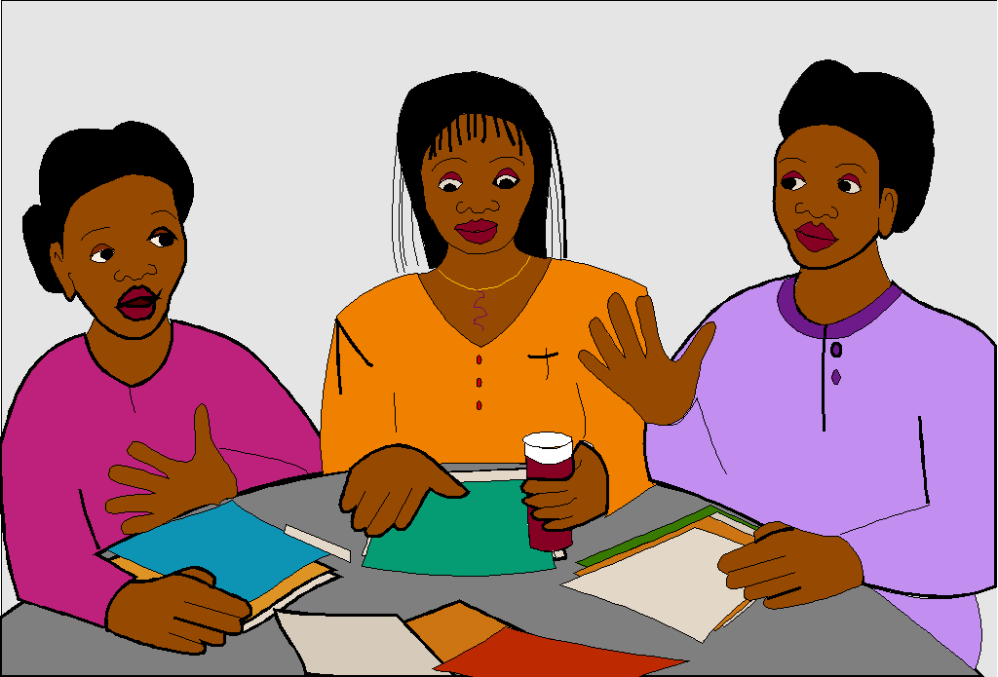
Advertise Through Your Personal Community Involvement
Nothing advertises
as well as
what you do!

Principles To Remember



- Be aware of your audience
- Brainstorming
- Organization
- Dress appropriately
- Interviews

Sample Press Release

Your name Immediate Release
Daytime phone number
Word count

Women’s Stress Seminar At Health Department

Do you ever feel like a fried piece of meat, pressed by a limp piece of lettuce, a tomato slice and two pieces of half-burned toast?

“The Sandwich Woman” is a no-cost (or if a fee is charged mention it later in the release) seminar to help women cope with the sandwiched feeling. The two hour seminar (or whatever time frame) will be presented by (name, title or other I.D. such as) Eleanor Bussy, M.D., a woman’s health specialist, is slated for (time) 7-9 P.M., Monday (date) April 10, (place) at the Moomey Health Department auditorium, 1700 Main Street.

Due to breakout sessions, to be facilitated by female nurse practitioners, attendance is limited to 40 (or whatever number). To register, call 545-9876 by Friday, April 7.

