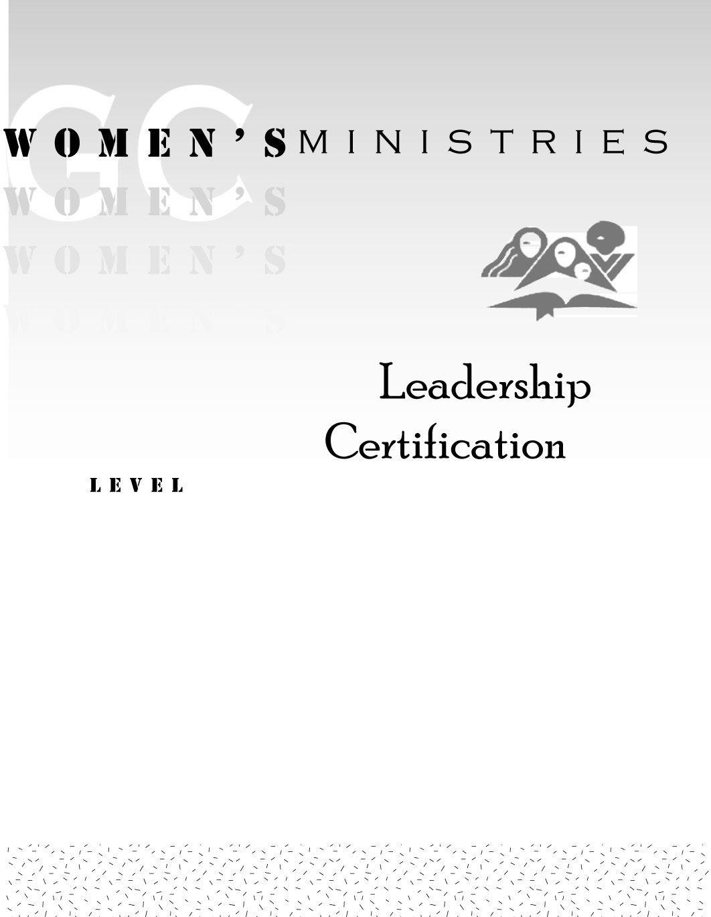
1
ADVERTISING
WOMEN’S
MINISTRIES

Betty Kossick

1
ADVERTISING
WOMEN’S
MINISTRIES

Handout

1
ADVERTISING
WOMEN’S
MINISTRIES

Overheads

Advertising Women’s Ministries

Overheads

