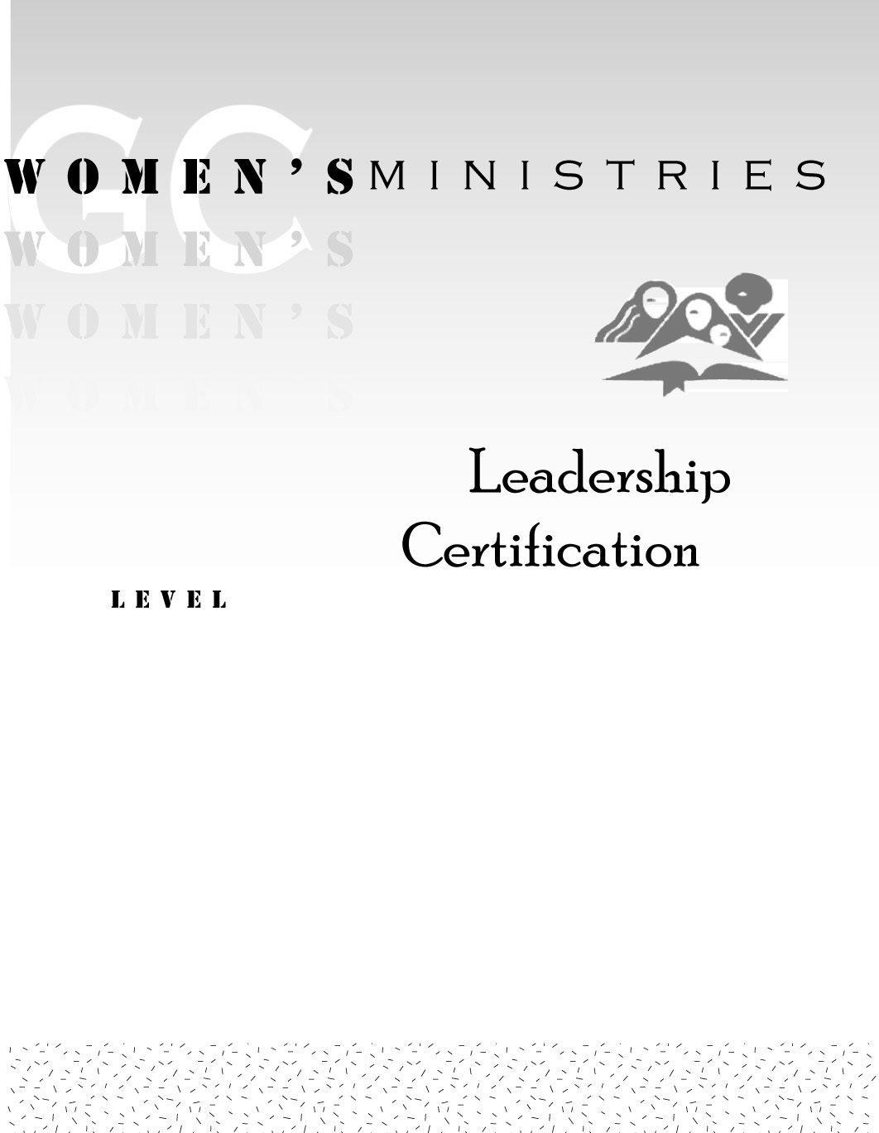
1
Basic Writing Skills

Betty Kossick

1
Basic Writing Skills

Handouts

Overheads
Basic Writing Skills
1

