A

Writer

Writes

For Readers

First Things First!

What is the Purpose
of your writing?

Who Is your Audience?

Knowing your

AUDIENCE

Helps you to determine the

STRATEGY

you will use.

Story Types You May Eventually Use

Press Release

News Story

Newspaper Feature Story

Magazine Feature Story

Narrative Writing

Devotional
Getting in Shape!

1. Write freely

Know your focus

The first thing you want to do is:

Capture the attention of your audience.
Who is the story about?

What is the story about?

Where does it take place?

When does it take place?

Why is it taking place?

How does it work?

2.
Write

with

Energy!

Writers are like
Gardeners
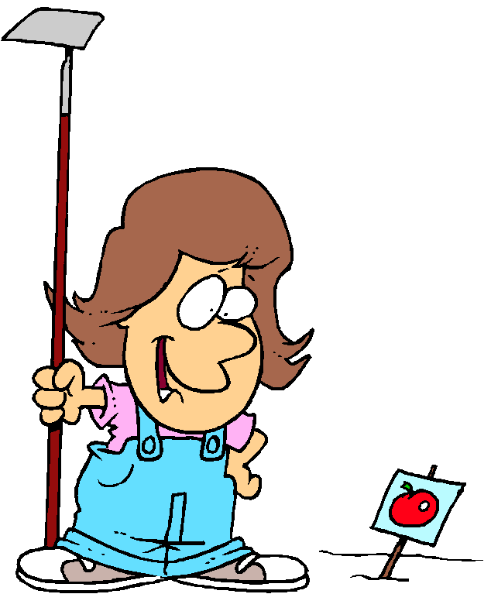

Common Weeds

Is Was Were Can
Has Have Had Should
Would Could

“To Be” words

“It was a dark and stormy night…”

“Stormy darkness gripped the night…”
Clichés
(Overused word or phrase)

Needle in a haystack

Busy as a bee

Straight as an arrow

Throw caution to the wind
3.
Brevity of Words

Avoid – long sentences and paragraphs

Aim toward tight writing

Redundancy

A huge throng of people gathered at twelve noon on Easter Sunday to debate the controversial issue.

A throng gathered at noon on Easter to debate the issue.
Redundancy

Soothing tranquilizer
Solution: tranquilizer

Is in need of
Solution: needs

Could hold practice
Solution: could practice

Consider the meaning of words!

Narrow down
(can you narrow up?)
Minor quibble
(quibble implies minor!)
Free gift
(it’s not a gift unless its free)

Practice asking yourself, “can I say this in less words?”

How would you shorten this:

other matters that were recommended

Can you shorten this?

two separate buildings

4. Rewrite, Rewrite, Rewrite!
5. Write for the editor’s needs.
- Teach with your writing.
- Self-editing
8. More self-editing!
9. Curiosity and caution
10. Interviewing for information.
11. Be patient!

“All good things come to those WRITERS who write while they wait.”

