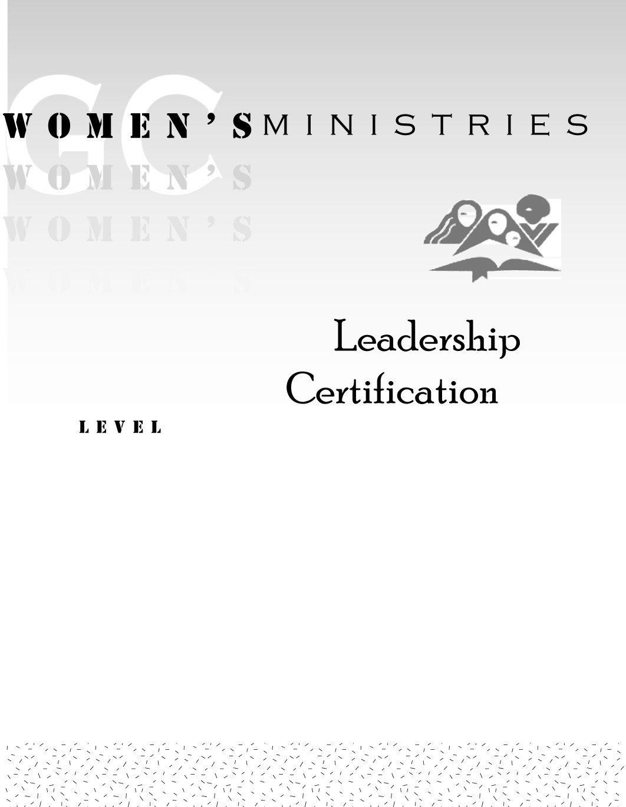
1
Communication and Conflict Management
Daphne Jean Thomas
Communication and Conflict Management
1

Handouts
1
Communication and Conflict Management
Overheads

Communication and Conflict Management

Overheads

