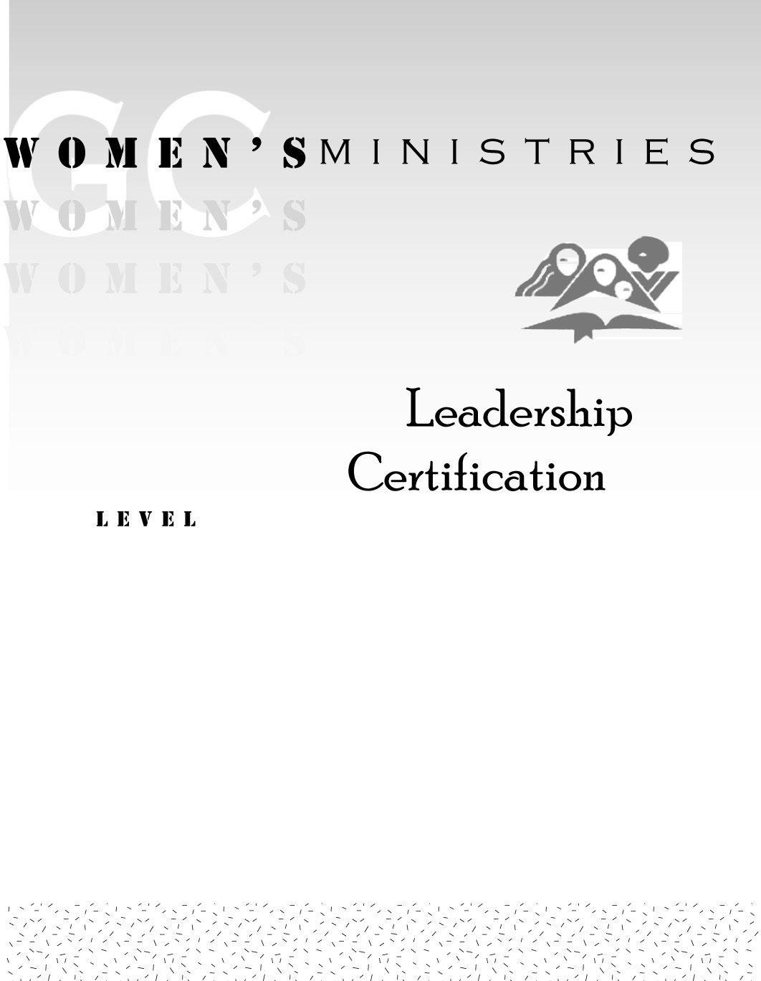
1
Communication
Skills

Daphne Jean Thomas

1
Communication
Skills

Handouts
1
Communication
Skills

Overheads

