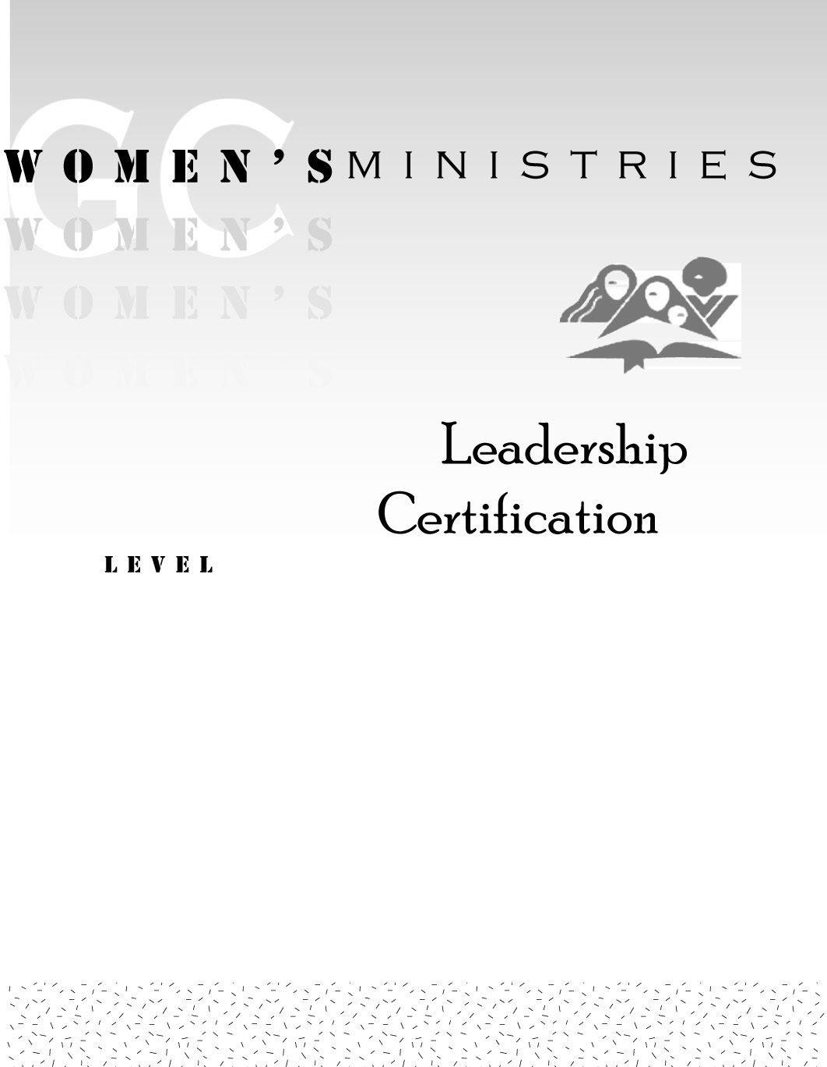
1
Principles of effective leadership

Marion Shields/Alice Rich

1
Principles of effective leadership

Handouts
1
Principles of effective leadership

Overheads

