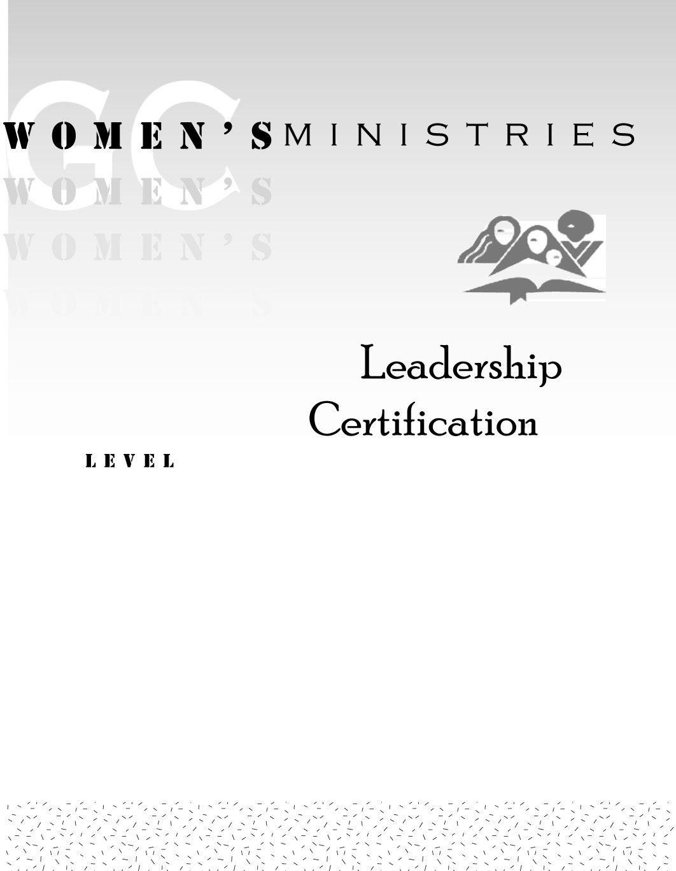
1
Effective Public Speaking

Nancy L. Van Pelt
1
Effective Public Speaking

Handouts
1
Effective Public Speaking

Overheads

