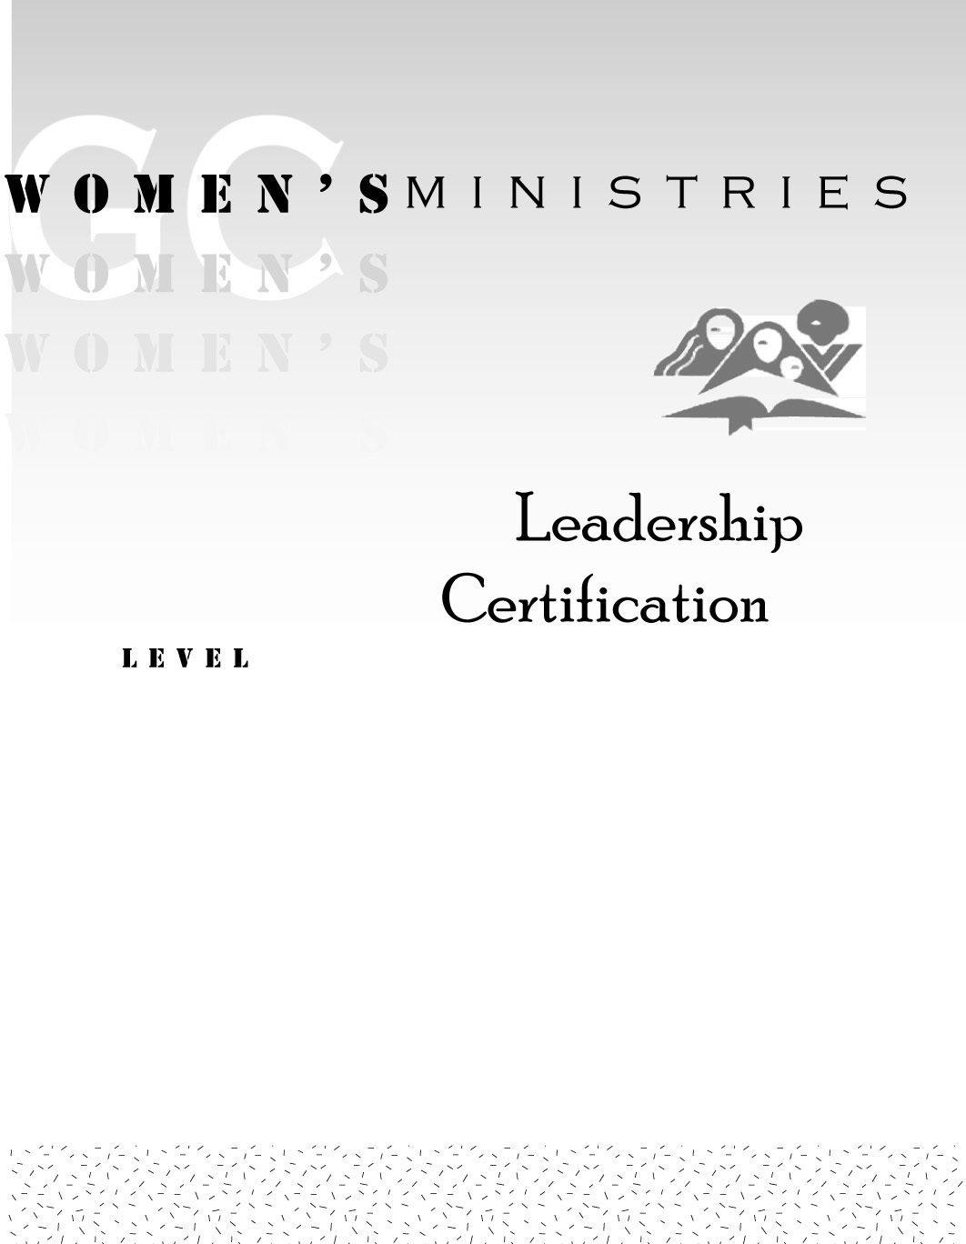
1
How To Study the Bible

Alice Rich

1
How To Study the Bible

Handouts
1
How To Study the Bible

Overheads

1
How To Study the Bible

Extra Materials

