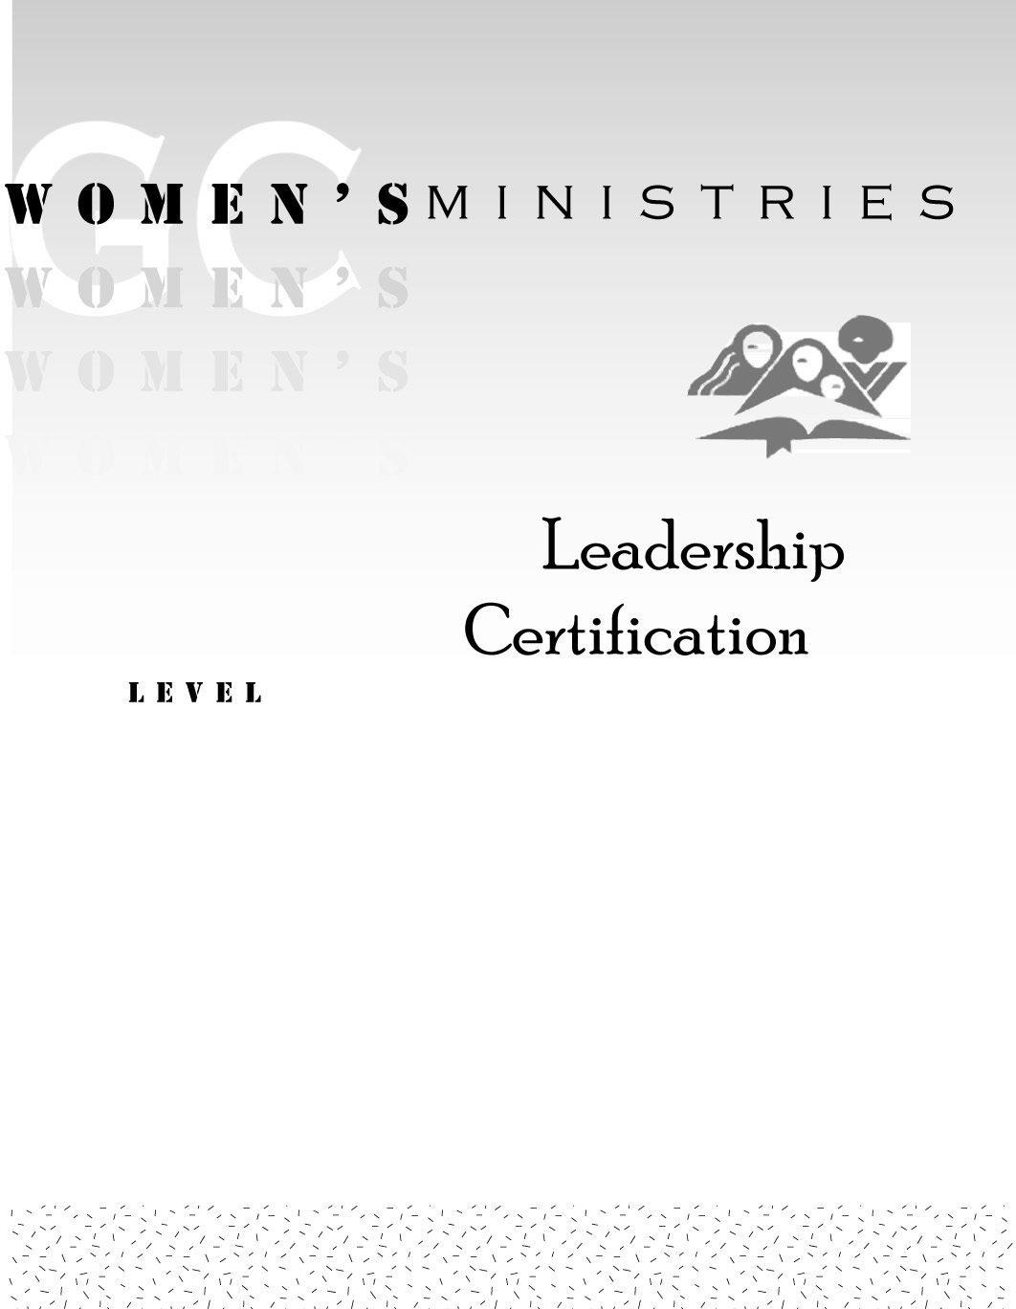
1
Introduction to Women’s Ministries

Dorothy Eaton Watts

1
Introduction to Women’s Ministries

Handouts
1
Introduction to Women’s Ministries

Overheads

