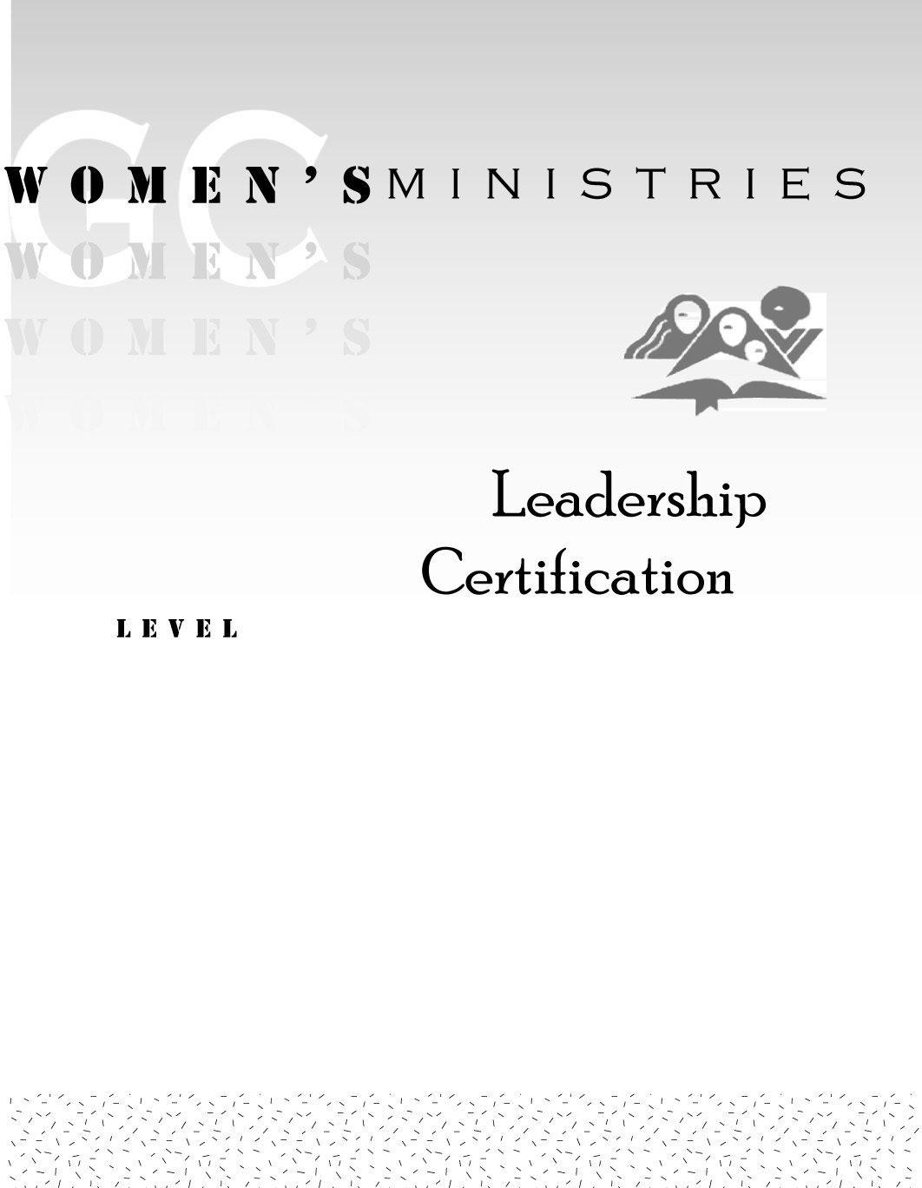
1
Women’s Needs Assessment in the Local Church

Evelyn Glass

1
Women’s Needs Assessment in the Local Church

Handouts
1
Women’s Needs Assessment in the Local Church

Overheads

Survey

