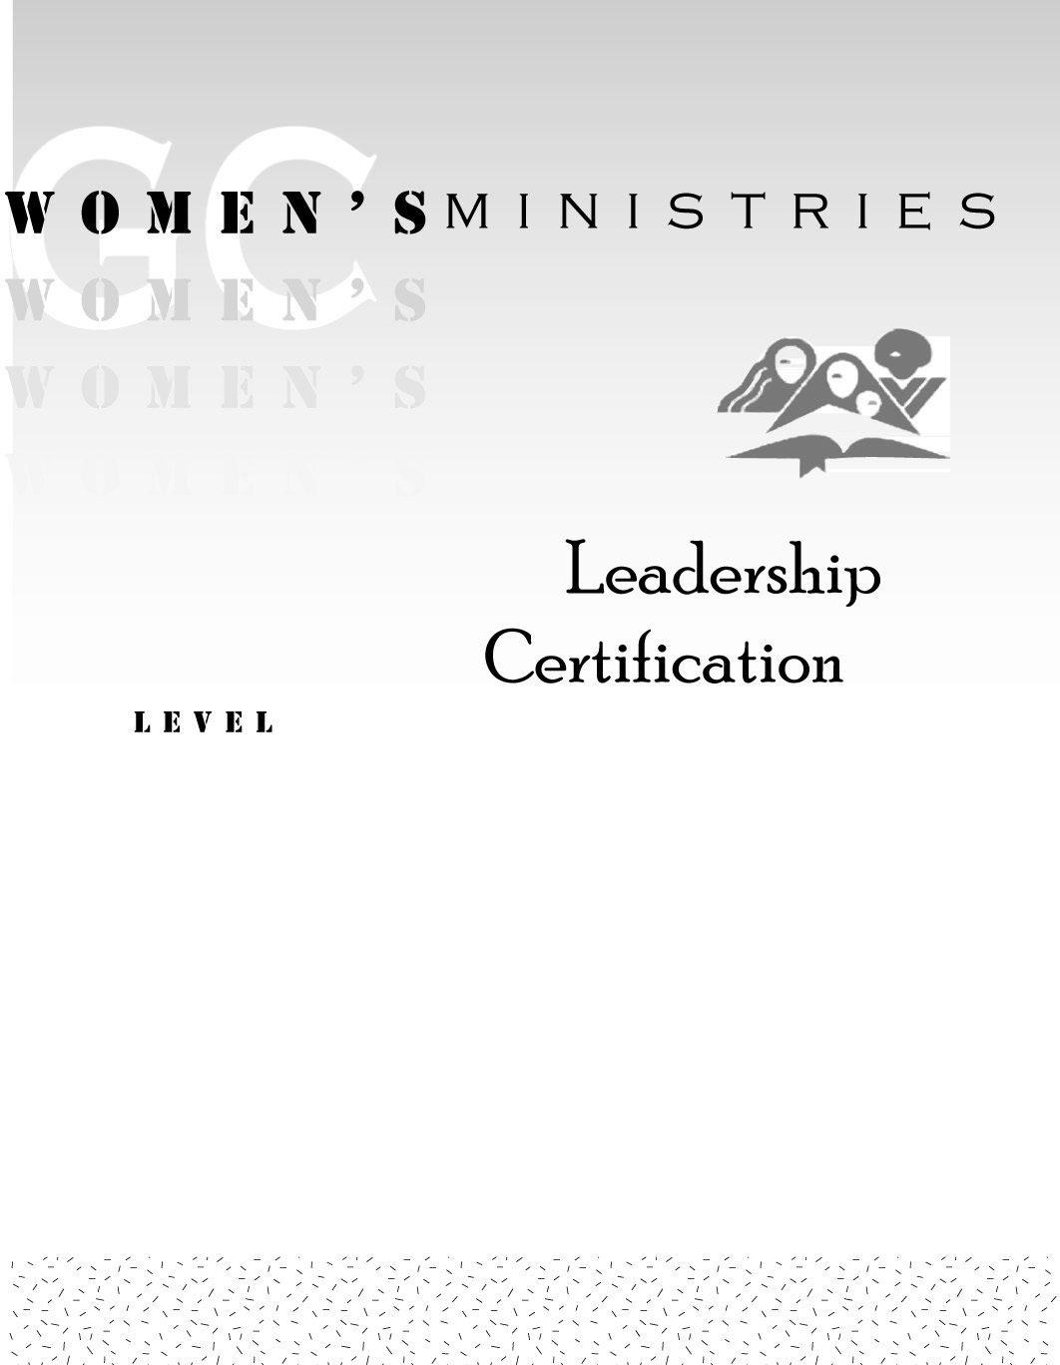
1
Organizing Retreats and Congresses

Linda M de Leon

1

Handouts
Organizing Retreats and Congresses
1

Overheads
Organizing Retreats and Congresses

