

General Conference of

Seventh-day Adventists

W O M E N ’ S M I N I S T R I E S

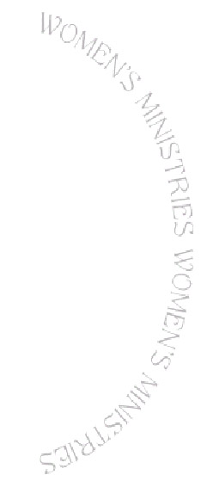


Leadership

Certificate

This is to certify that
has successfully completed the

General Conference of Seventh-day Adventists

Women’s Ministry Leadership Certification

LEVEL 1

Mary Ann Joseph

