T
Write words in the blank spaces that describe characteristics of teenage girls.
Characteristics of Teenage Girls

Physically

Personality/Attitude

Socially

Spiritually
Needs of Teenage Girls

Physically

Personality/Attitude

Socially

Spritually
The KING’s
DAUGHTER
is all
GLORIOUS
WITHIN
psalm 45:13 kjv

PSALM 139:13 – 16

For you created my inmost being;
you knit me together in
my mother’s womb.
I praise you because I am fearfully and wonderfully made;
your works are wonderful,
I know that full well.
My frame was not hidden from you
when I was made in the secret place.
When I was woven together
in the depths of the earth,
your eyes saw my unformed body.
All the days ordained for me
were written in your book
before one of them came to be.

--New International Version
THINGS TO CONSIDER
WHEN CHOOSING A PROFESSION

1. It must be something you genuinely like to do. This choice requires you to identify your own strengths, weaknesses, and interests. (Some excellent psychometric tests are available to help with this need.)

2. It must be something you have the ability to do. You might want to be an attorney but lack the talent to do the academic work and pass the bar examination.
3. It must be something you can earn a living by doing. You might want to be an artist, but if people don’t buy your paintings, you could starve while sitting at your easel.

4. It must be something you are permitted to do. You might make a wonderful physician and could handle the training but can’t gain entrance to medical school.

5. It must be something that brings cultural affirmation. In other words, most people need to feel some measure of respect from their contemporaries for what they do.

6. Most importantly for the genuine believer, it must be
something that you feel God approves of.

--Dr. James Dobson in Life on the Edge p. 11
I’m part of
a new generation!!

I’m my own person!!

You
may
choose
the action.
You cannot
choose the
consequences!
How to Know God’s Will

FIRST - talk to another person about the decision to be made: discuss it with someone in whom you have confidence and with whom you can share your ideas.

SECOND - read the Bible for direction. God will talk to you through His Scriptures, and He will never ask you to do anything that contradicts His Word.

THIRD - watch to see which doors open and which slam shut. If God is leading you in a particular direction, He’ll work through what we call “providential circumstances.” He will create opportunities for you to do what He wants. You won’t have to “hammer down” the obstacles if God is involved.

FOURTH - give yourself plenty of time to think. Don’t make any big decisions while you’re in a state of confusion. That’s a good principle to follow throughout your life. When you’re not sure what to do, avoid the final choice for as long as possible. You might have much greater confidence a few days later.

FIFTH - pray for God’s guidance and blessing and leading.
–Dr. James Dobson

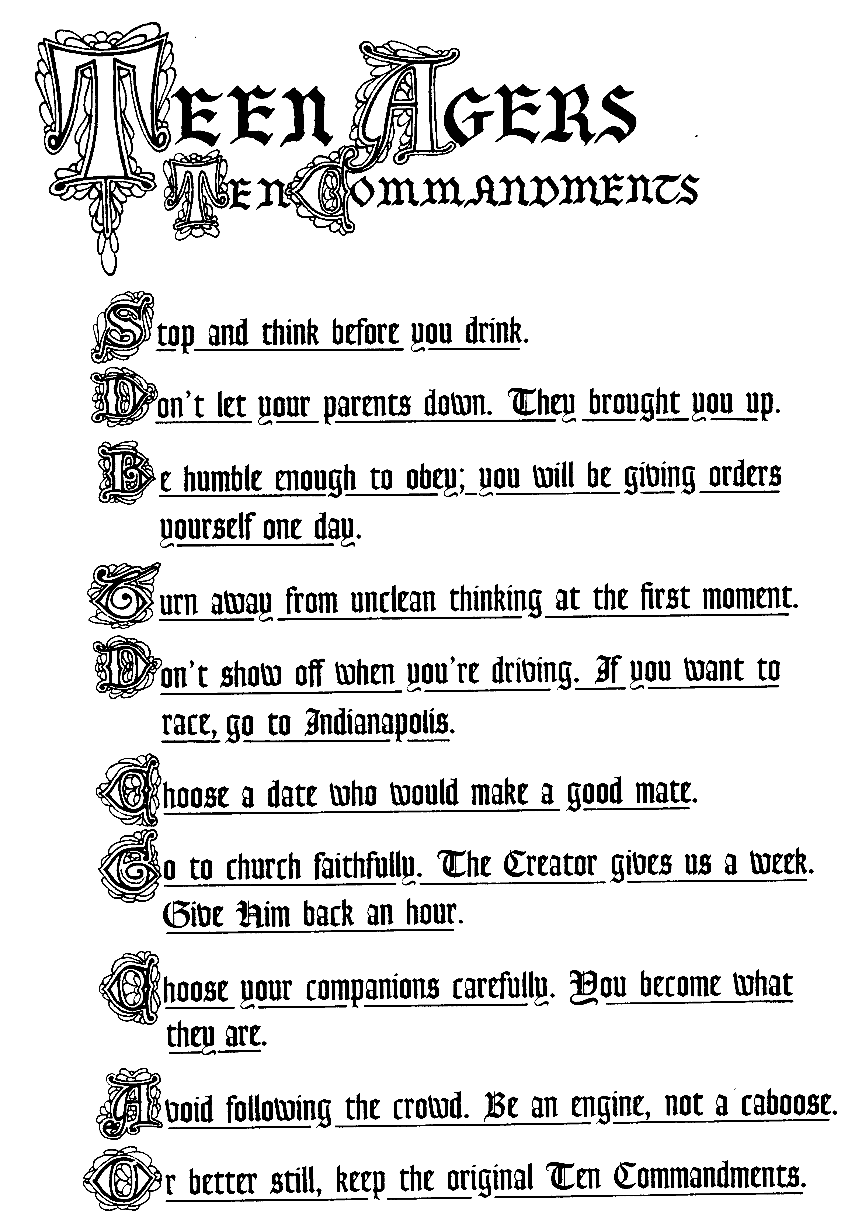
Here’s Who I Am …
 | My Strengths | My Weakness
Appearance
Character
Personality
Abilities
Achievements
Talents
Spiritual Qualities

