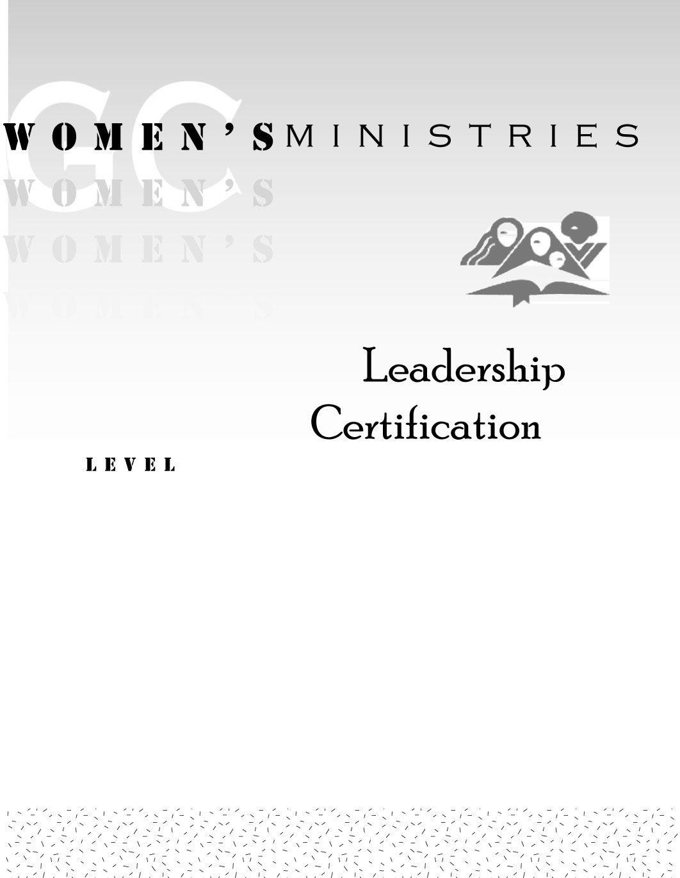
1

Writing Letters

Tamyra Horst

1

Writing Letters

Handouts

1
Writing Letters

Overheads

