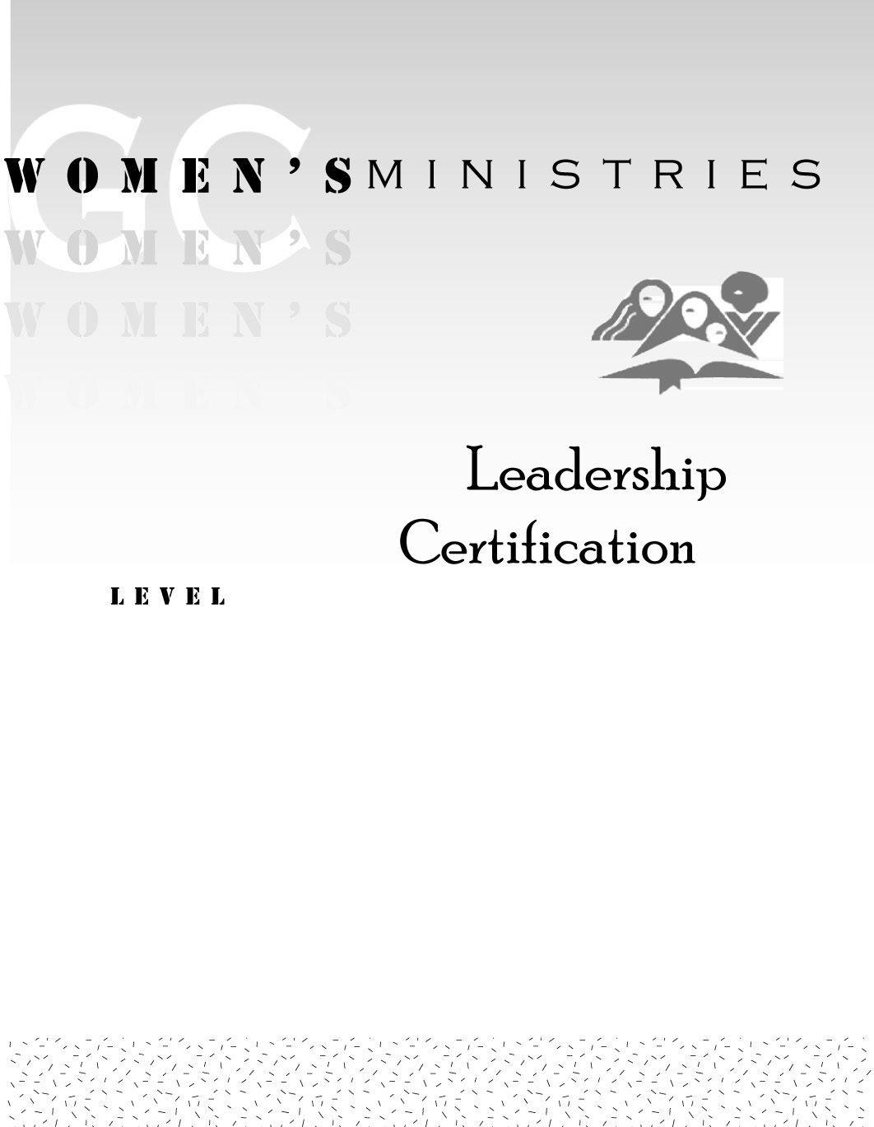
1
Women’s Needs Assessment in the Local Community

Evelyn Glass

1
Women’s Needs Assessment in the Local Community

Handouts
1
Women’s Needs Assessment in the Local Community

Overheads

Survey

