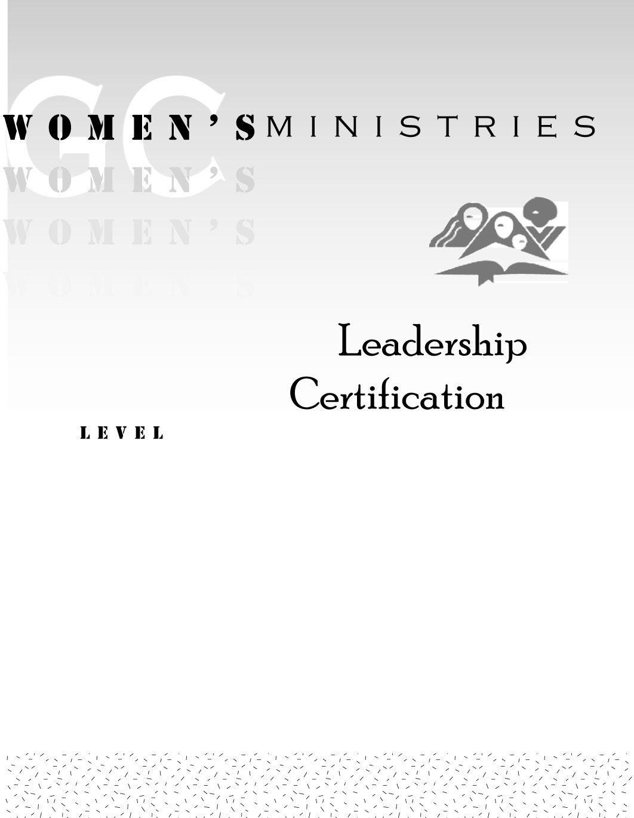
1
A Woman of Worth
Dorothy Eaton Watts

1
A Woman of Worth

Handout

1
A Woman of Worth

Overheads

