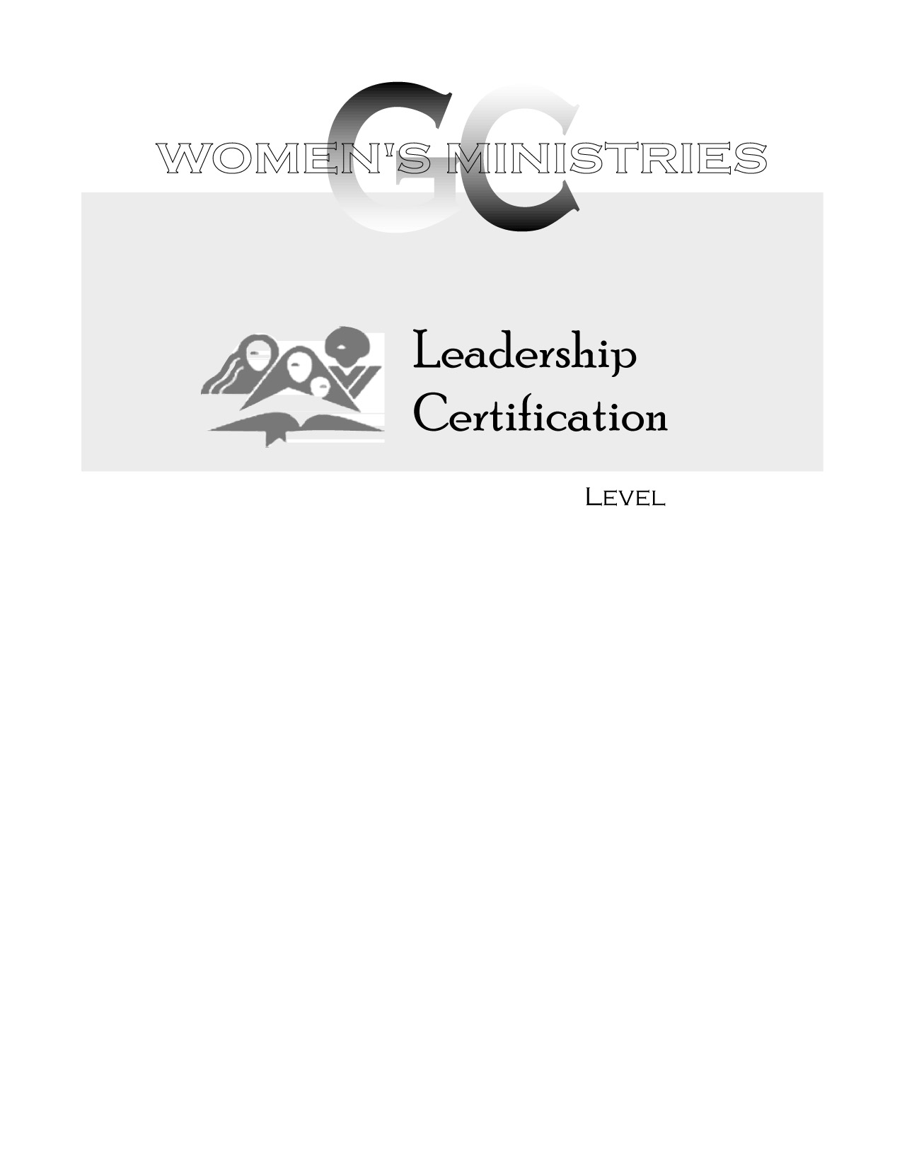
2
Assessing and Using Community Resources for Women

Minnie McNeil
2
2
Assessing and Using Community Resources for Women

Overheads
2
Assessing and Using Community Resources for Women

Handouts

