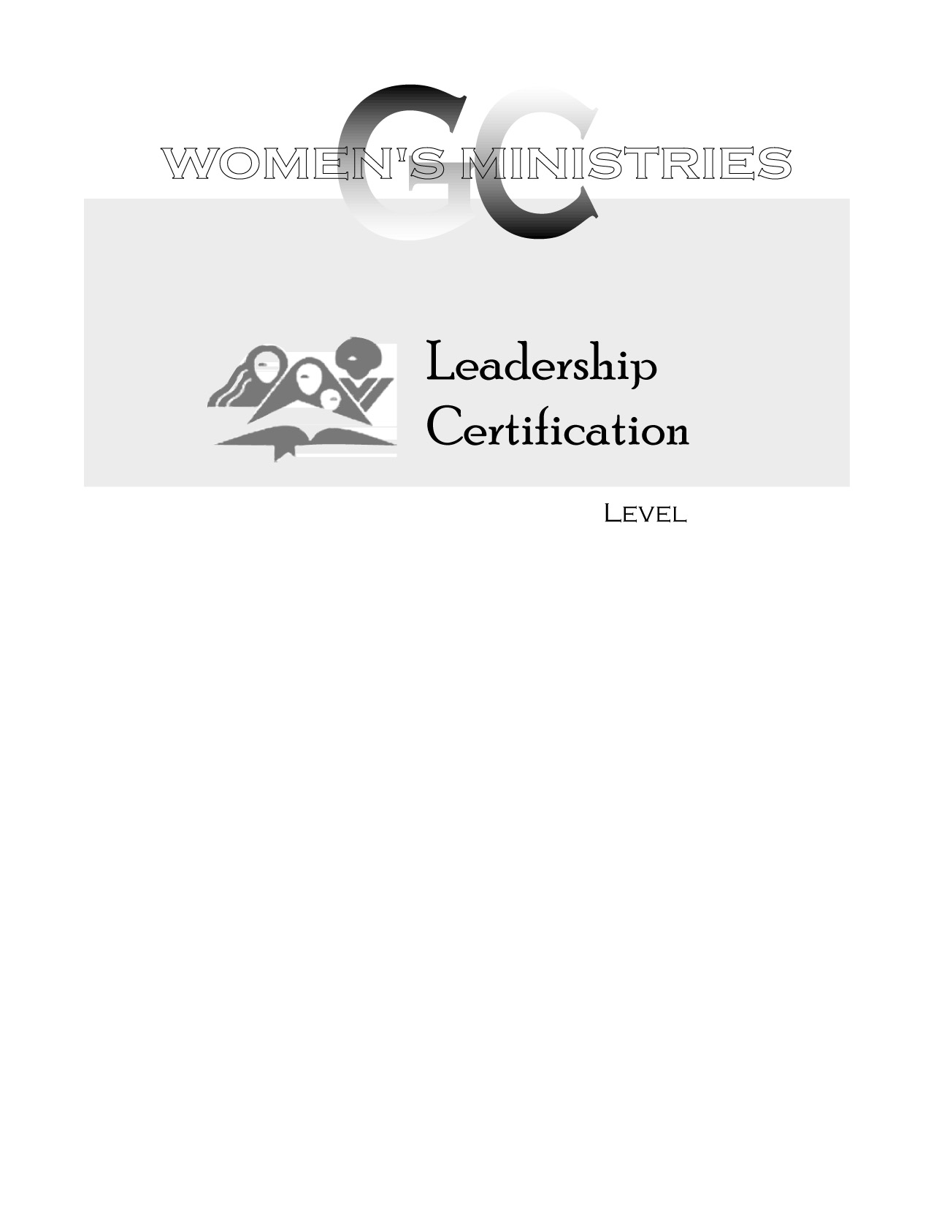
2
Effective Leadership in Meetings, Committees, and Boards

Overheads
2

2
Effective Leadership in Meetings, Committees, and Boards

Rose Otis
2
Effective Leadership in Meetings, Committees, and Boards

Handouts

