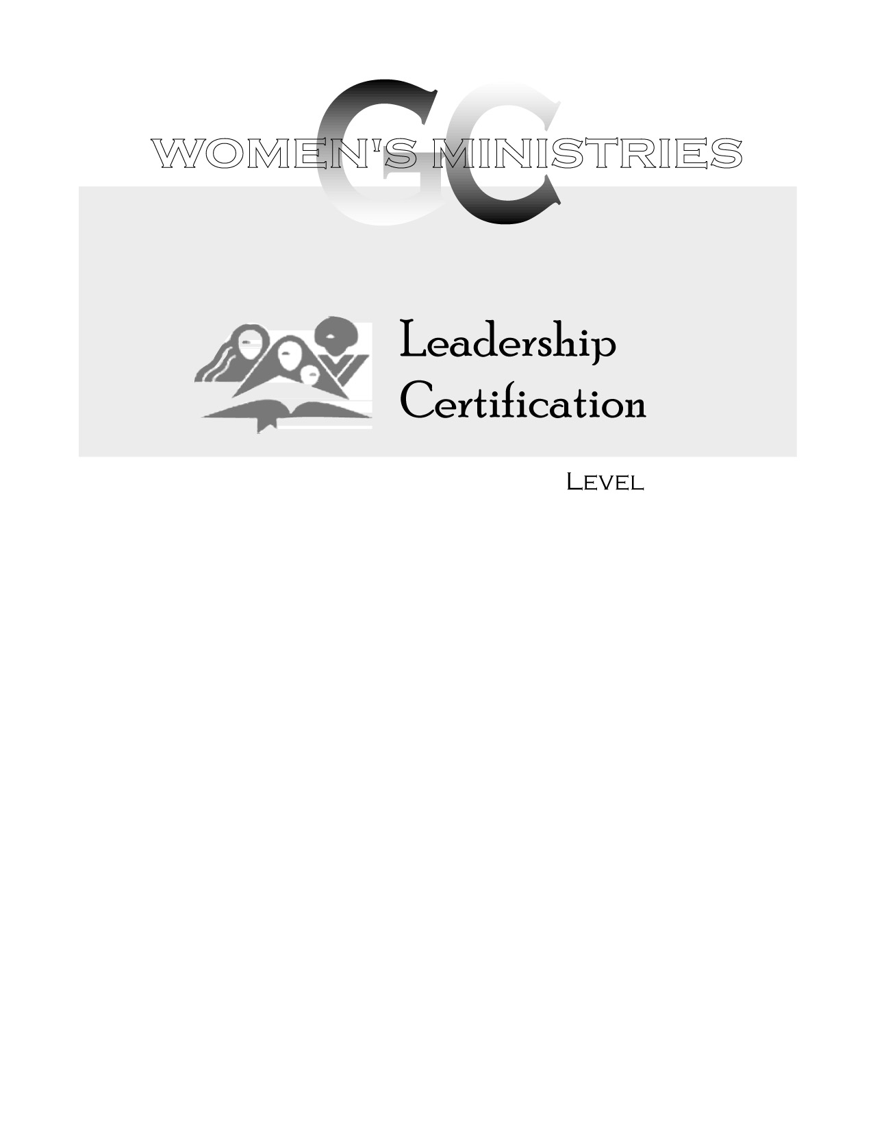
2
Literacy Training

Overheads
2
Literacy Training

Handouts
2
Literacy Training

Ardis Dick Stenbakken

