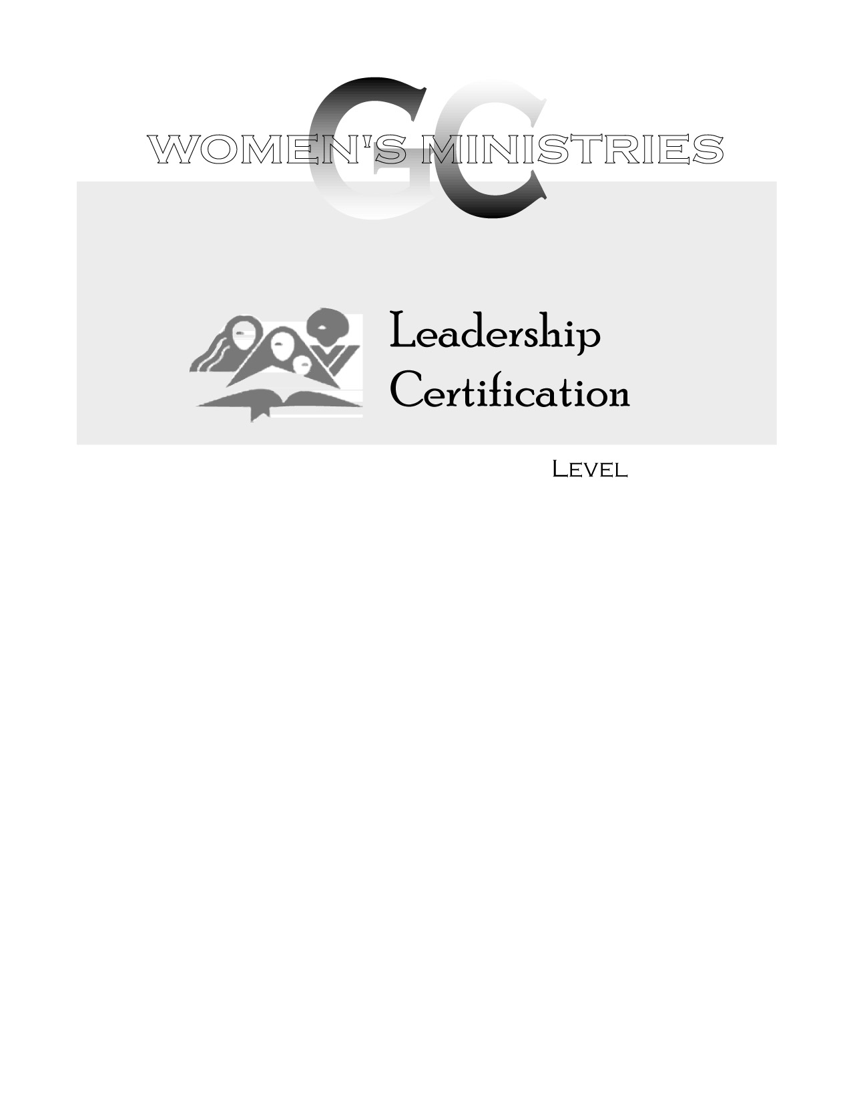
2
Principles of Counseling

Gloria Trotman
2
2
Principles of Counseling

Overheads
2
Principles of Counseling

Handouts

