Definition of Philosophy

- Love and pursuit of wisdom by intellectual investigation and moral self-discipline
- Inquiry into laws and causes underlying reality
- Inquiry into the nature of things based on logical reasoning rather than empirical methods
- Analysis and critique of fundamental beliefs as they come to be conceptualized and formulated
- The synthesis of all learning
- All learning except practical arts and technical precepts
- A system of fundamental or motivating principles: basis of action or belief
- The overall values by which one lives

The biggest challenge is to help women, and men, understand that it is not a social club, not a women’s society, but a ministry.

Women’s Ministries is a ministry that nurtures, supports, and inspires women in a unique and personal way.

Ministry for Whom?

List as many categories as you can:

Categories of Women

- Young mothers
- Single women
- Professional women
- Lay workers
- Church employees
- Widows
- Physically challenged women
- Divorced woman
- Pastor’s wives
- Abused women
- Burned out church volunteers
- Women caring for both children and parents
- Women feeling guilty because their children have left the church
- Teens and collegiate women
- Single mothers

FW 05 Philosophy

The Department of Women's Ministries is committed to encouraging, challenging,
equipping, and nurturing Seventh-day Adventist women as they do their part in carrying
the Gospel message to the world.



FW 10 Purpose

The primary purpose of the Department of Women's Ministries is to nurture, facilitate, and support women in their Christian lives as disciples of Jesus Christ and members of His World Church. In consultation with administration and other departments of the Church, the department shares the responsibility for developing a global evangelistic strategy and provides training to equip the women of the church to uplift Christ in the Church and in the world.

The Department of Women’s Ministries will focus on the six critical issues that have been identified as barriers preventing women from reaching their full potential: illiteracy, poverty, risks to health, abuse, length of workday and poor working conditions, and the need for training and mentoring for greater involvement in the mission of the Church.

FW 15 10 Objectives

- Liaison and cooperate with other specialized departments of the church to meet the needs of women.



FW 20 15 Responsibilities of Director

2. The director shall represent, and serve as advocate for, departmental goals, programs, and activities to the administrative bodies of the Church; shall represent administrative viewpoints to the departmental staff; and shall serve as liaison between other departments and the Department of Women's Ministries.

The Women's Ministries Committee

The Women's Ministries leader works with the pastor and church board to establish a Women's Ministries Committee to foster a ministry to women in the church. This committee should be composed of persons interested in the broad spectrum of women's needs and services. To form a balanced team, the members should be persons with varied talents and experience. The major responsibilities of the Women's Ministries Committee will be the following:

- To assess the needs of women in the local church and community, by utilizing surveys and interviews, and in counsel with the pastor and church leaders;
- To brainstorm, develop strategies, and cooperate with other specialized departments of the Church to foster programs and activities which minister to women;
- To plan and implement these and other initiatives which relate to women's specific and varied needs, in cooperation with the pastor, departmental specialists, and other church leaders;

- To facilitate local church participation in annual programs and activities initiated by the conference/union/division/ General Conference such as the International Women's Day of Prayer, Women's Ministries Day, and small group ministries to support and encourage them in service. Information regarding these programs is available through the conference/mission Department of Women's Ministries.

Assumptions that Affect Philosophy:

Assumptions about women in general:
- Relationally oriented
- Need support and reinforcement of other women in similar situations
- Tend toward intimacy
- Like to talk and share opinions
- Want to feel needed, respected, and appreciated
- Often suffer from low self-esteem and self-confidence
- Often competitive and comparative, especially toward other women

8. May gossip and complain unless directed constructively
- Oriented toward self improvement
- Need role models
- Are busy: family, personal and career responsibilities
- Want relevancy-will join if a ministry interests them
- Have practical needs
- Have specific needs in various stages in their lives

There are also some spiritually oriented assumptions:

- Women matter to God
- Jesus Christ is the example of how women should be treated
- Women are sensitive to spiritual feeding
- God is the ultimate solution to their problems and their attitudes
- Women matter to the Seventh- day Adventist Church
- Women are at a variety of levels in spiritual growth
- Women have been involved in the mission of the church in the past. Leadership and involvement are not new.

“Every born-again believer should have a ministry.
Therefore go and make disciples of all nations, baptizing them in the name of the Father and of the Son and of the Holy Spirit, and teaching them to obey everything I have commanded you. And surely I am with you always, to the very end of the age.” Matthew 28:19, 20.

The Adventist Church teaches the priesthood of all believers:
But you are a chosen people, a royal priesthood, a holy nation, a people belonging to God, that you may declare the praises of him who called you out of darkness into his wonderful light. 1 Peter 2:9.

The Bible instructs women to minister to each other:

“Teach the older women to be reverent in the way they live, not to be slanderers or addicted to much wine, but to teach what is good. ⁴Then they can train the younger women to love their husbands and children, ⁵to be self-controlled and pure, to be busy at home, to be kind, and to be subject to their husbands, so that no one will malign the word of God.” Titus 2, 3-5.

- The world has changed for women
- We need to help women find their spiritual gifts
- We must be creative in developing ministries
- Ministries should be needs-based
- Most women don’t have time for another meeting

“Christ’s method alone will give true success in reaching the people. The Savior mingled with men as one who desired their good. He showed His sympathy for them, ministered to their needs, and won their confidence. Then He bade them, ‘Follow Me.’” Ministry of Healing, p. 143.

- It is important to provide leadership training and mentoring
- Women’s Ministries consists of everything women do in the church
- There is a wide variety of ministries available

“Christ’s method alone will give true success in reaching the people. The Savior mingled with men as one who desired their good. He showed His sympathy for them, ministered to their needs, and won their confidence. Then He bade them, ‘Follow Me.’”
Ministry of Healing, p. 143.

Six Challenge Issues Facing Women

http://wm.gc.adventist.org 

- Poverty
- Health risks
- Literacy
- Work load
- Abuse
- Leadership training and mentoring



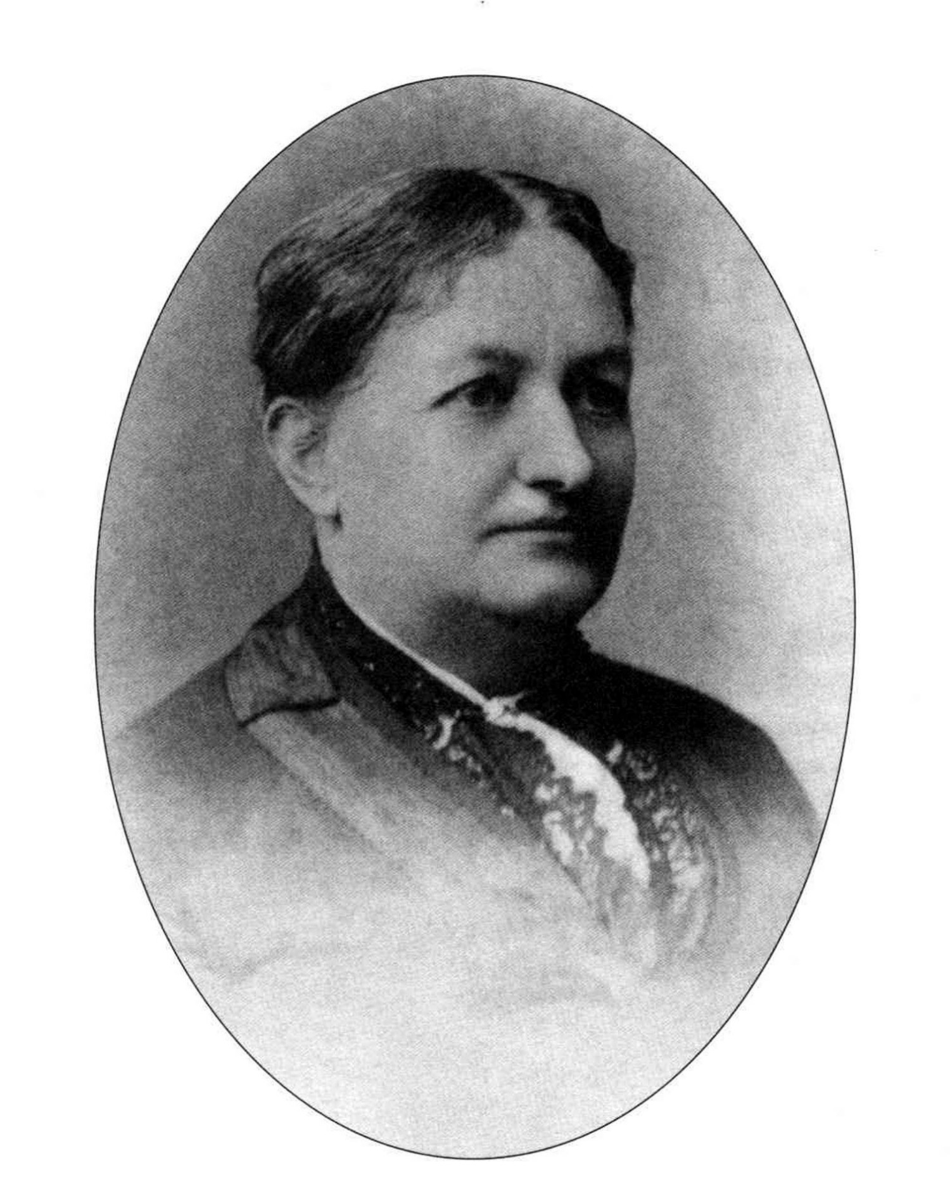

SMI Henry
1839 – 1900

“When a great and decisive work is to be done, God chooses men and women to do this work, and it will see the loss if the talents of both are not combined.” Evangelism, p. 469.

“There never was a time when more workers were needed than at the present. There are brethren and sisters throughout all our ranks who should discipline themselves to engage in this work; in all our churches something should be done to spread the truth. It is the duty of all to study the various points of our faith.” Review and Herald, April 1, 1880.

“All who work for God should have the Martha and the Mary attributes blended – a willingness to minister and a sincere love of the truth. Self and selfishness must be put out of sight. God calls for earnest women workers, workers who are prudent, warmhearted, tender, and true to principle. He calls for persevering women who will take their minds from self...and will center them on Christ, speaking words of truth, praying with the persons to whom they can obtain access, laboring for the conversion of souls.” Testimony Treasures, Vol. 2, p. 405.

“Women can be instruments of righteousness, rendering holy service. It was Mary that first preached a risen Jesus....If there were twenty women where now there is one, who would make this holy mission their cherished work, we should see many more converted to the truth. The refining, softening influence of Christian women is needed in the great work of preaching the truth.”
Evangelism, pp 471, 472.


“The Lord has a work for women as well as men to do. They may accomplish a good work for God if they will first learn in the school of Christ the precious, all-important lesson of meekness. They must not only bear the name of Christ, but possess His Spirit. They must walk even as He walked, purifying their souls from everything that defiles. Then they will be able to benefit others by presenting the all-sufficiency of Jesus.” Testimony Treasures, Vol 2, p. 404.

“He will raise up from among the common people men and women to do His work, even as of old He called fishermen to be His disciples. There will soon be an awakening that will surprise many. Those who do not realize the necessity of what is to be done will be passed by, and the heavenly messengers will work with those who are called the common people, fitting them to carry the truth to many places.”
15 MR 312 (1905).

“Women who have the cause of God at heart can do a good work in the districts in which they reside. Christ speaks of women who helped Him in presenting the truth before others, and Paul also speaks of women who labored with Him in the gospel. But how very limited is the work done by those who could do a large work if they would.”
Evangelism, p. 465.

“In the last days, God says,
I will pour out my Spirit on all people.
Your sons and daughters will prophesy,
your young men will see visions,
your old men will dream dreams.
Even on my servants, both men and women,
I will pour out my Spirit in those days,
and they will prophesy.”
Acts 2: 17, 18.



