The focus of a program is

Planning a program can be compared to an artist painting a picture.

Likewise, we ask:

- What do we want to portray?

- What do we want them to remember?

We are only God’s instruments. This is His program. He is using us to plan it.

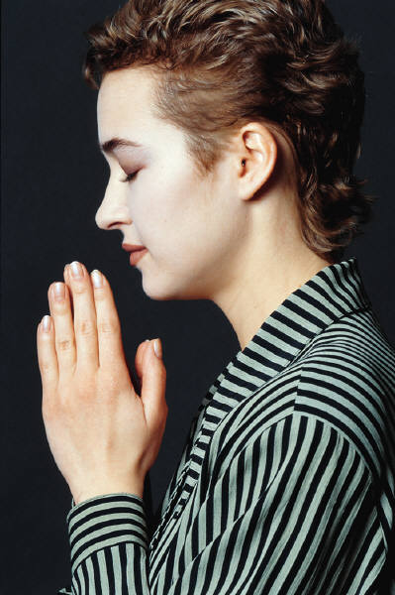

PRAYER,

PRAYER, PRAYER,
And More Prayer!

Frequently Asked Questions

Where do I start?

How can I ensure effectiveness?

Will people want to come?

What will make the program attractive?

How will I evaluate its success?

What is the best advertising method?

Is there a budget?

Step #1: Form a Planning Committee



a. Support: moral, spiritual, physical

b. Balance

Choosing a Balanced Committee



Personal Contact

- Consult with the church pastor and others you trust.

Size of Committee

Large does not necessarily mean effective.

Composition of a Committee
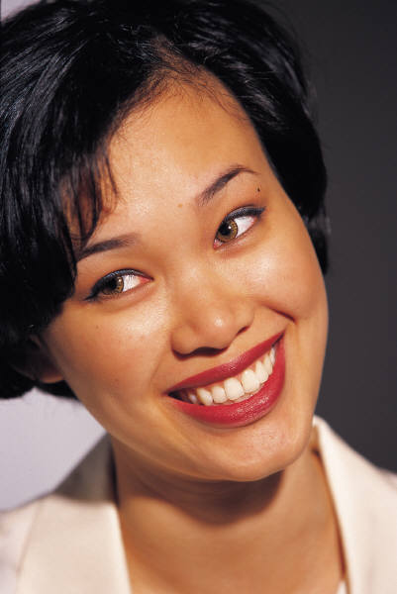
- The leader/chairperson

- A young woman

- A single woman

- A career woman who is presently working at her career

- A homemaker who happens to be a mother

- A senior citizen

Step 2: Choosing the Theme

Needs Assessment Exercises:

- Exercise # 1: Identify Three Needs

- Exercise #2: Prioritize the Needs

- Exercise #3: List Group Needs

- Exercise #4: Prioritize Group
Needs

- Exercise #5: Identifying the
Theme

Principles of Program Planning

- Christ-Centered

Organization

Relevant

- Simplicity

- Interesting/vibrant

- Theme focused

- Music

- Attention to details

What to Avoid:

Jargon and complex religious phrases
- Negatives
- Lifelessness—Monotone sends everyone to sleep
- Packing the Program: “effective” and “packed” are not synonymous
- Numerous Announcements
- Neglecting time: A great motto is “Start and End on Time.”
- Lengthy introductions

Keyword

Advertise!

Advertise! Advertise! Advertise!

Advertising Principles

- Repetition
- Brochure
- Brochures sent to churches
- Newspaper/radio advertisement

Subcommittees and Responsibilities

- Program
- Hospitality
- Audio Visual
- Ushering
- Music
- Photographer/
Videographer
- Clean up crew
- Registration
- Decoration
- Prayer

