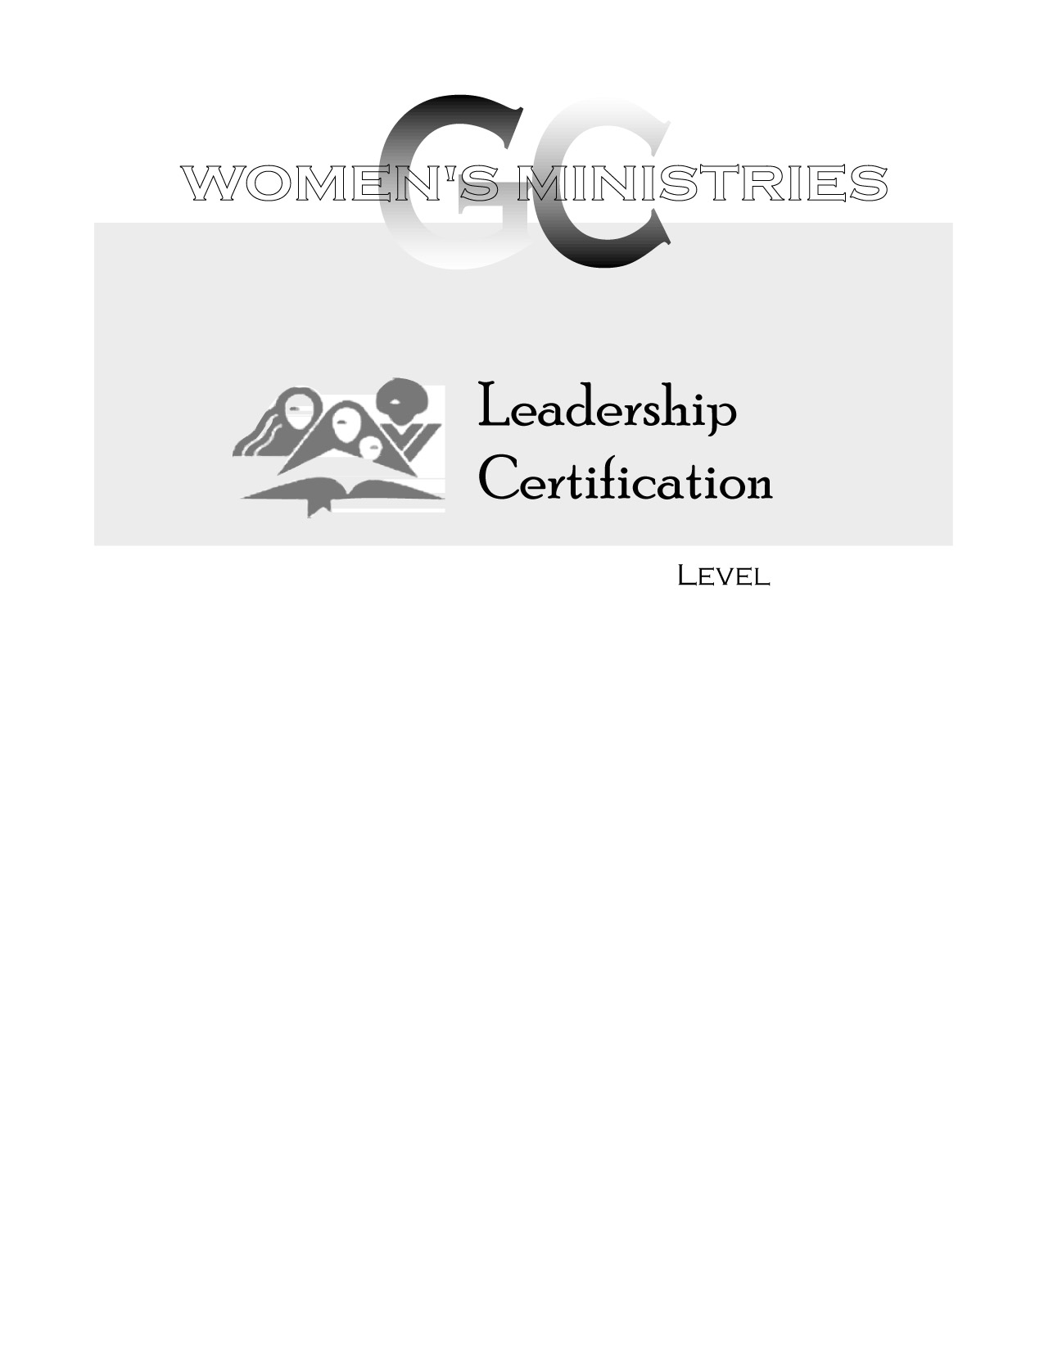
2
Principles of Visitation

Joy Butler
2
2
Principles of Visitation

Overheads
2
Principles of Visitation

Handouts

