Know Your Place In the Body of Christ

"You are Christ's body—that's who you are. You must never forget this. Only as you accept your part of that body does your ‘part’ mean anything. You're familiar with some of the parts that God has formed in His church, which is His `body': apostles, prophets, teachers, miracle workers, healers, helpers, organizers, and those who pray in tongues. But it's obvious by now, isn't it, that Christ's church is a complete body and not a gigantic, uni-dimensional part?” Cor. 12:27, 28.
Why Visit?

- There are people who need us
- God has asked us to do this
- Because we love to do it
- To bear each other's burdens
- Because there is personal joy and satisfaction in helping others

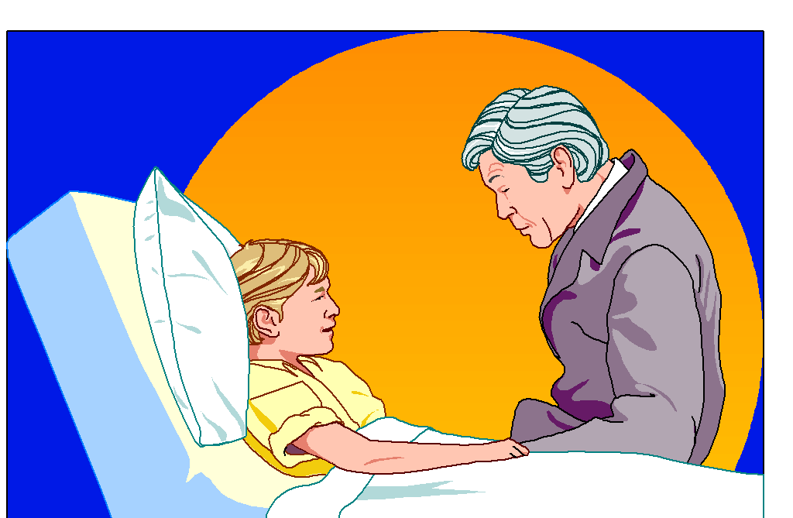
Qualities of Visitors or Helpers

"Examine yourselves as to whether you are in the faith" 2 Cor. 13:5 RAV.

"Be hospitable to one another without grumbling. As each one has received a gift, minister it to one another, as good stewards of the manifold grace of God. “
1 Peter 4:9, 10 NKJV



Approach Others in Distress With…

- Sensitivity and empathy
- Flexibility
- Genuineness
- Acceptance of differences

Develop Good Communication Skills

- Listening focuses on what the person is saying.
- Reflect the feelings.
- Listen for themes in the conversation.
- Avoid noxious words.
- Watch for nonverbal communication.

Be Aware of and Practice Ethical Behavior

- Maintain Confidentiality
- Power
- Boundaries

Principles of Spiritual Care

- Help the person understand their situation
- Know the difference between sadness and depression
- Know the basics of salvation – theological training not a prerequisite


Home Visitation

- The Entrance
- Sitting Down
- The Discussion
- Length of Call
- Visiting the Shut-In
- Guidelines for Making Initial Visits

Types of Visitation

- Visiting a Church Member
- Cancer Patients
- Maternity/New Babies
- Sick Babies and Children
- Still Births, Miscarriage, and Neonatal Deaths
- The Dying Patient

