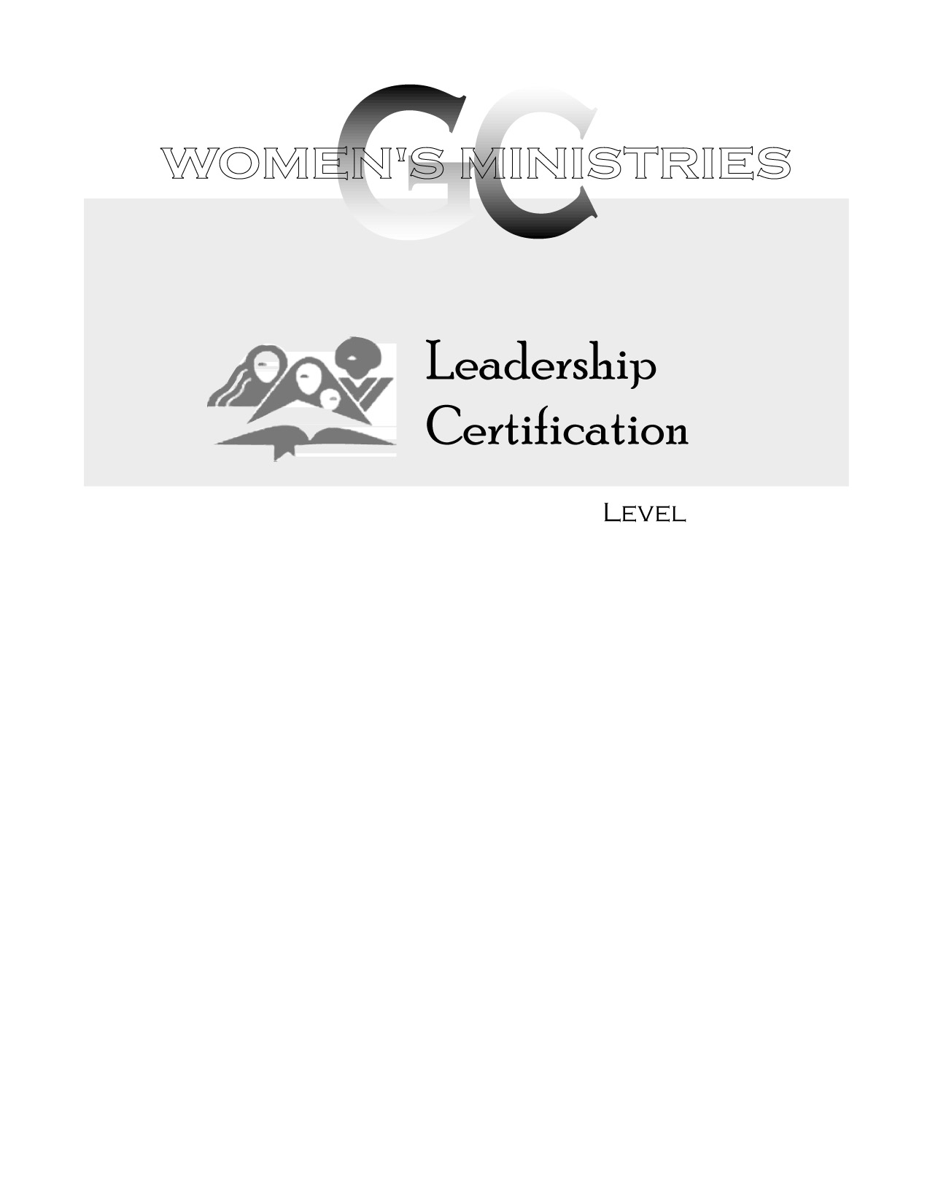
2
Philosophy of Women’s Ministries: Roles and Objectives

Ardis Dick Stenbakken
2
2
Philosophy of Women’s Ministries: Roles and Objectives

Overheads
2
Philosophy of Women’s Ministries: Roles and Objectives

Handouts

