“Suppose one of you has a hundred sheep and loses one of them. Does he not leave the ninety-nine in the open country and go after the lost sheep until he finds it? And when he finds it, he joyfully puts it on his shoulders and goes home. Then he calls his friends and neighbors together and says, ‘Rejoice with me; I have found my lost sheep.’”

Luke 15:4-6 (NIV)
“Or suppose a woman has ten silver coins and loses one. Does she not light a lamp, sweep the house and search carefully until she finds it? And when she finds it, she calls her friends and neighbors together and says, ‘Rejoice with me; I have found my lost coin.’”
Luke 15:8, 9 (NIV)

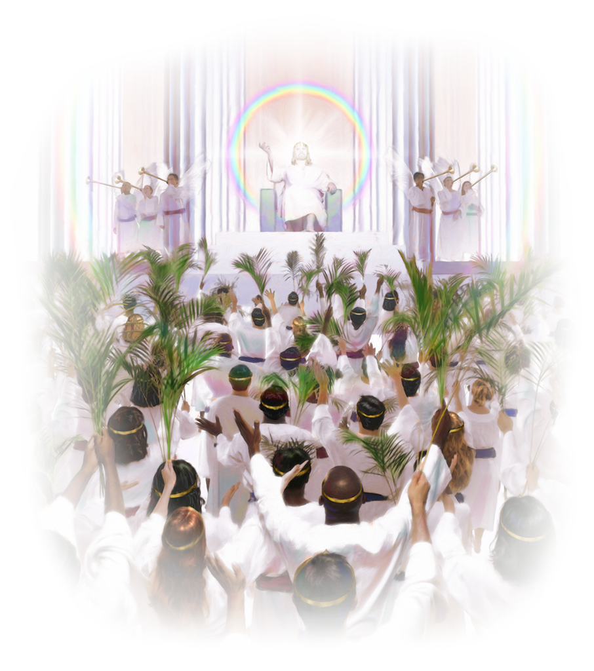
“In the same way, I tell you, there is rejoicing in the presence of the angels of God over one sinner who repents.” Luke 15:10 (NIV)
- Sometimes it only takes one contact to bring back a missing member.
- Most missing members, however, need time to heal, time to know the church cares, and time to grow in their relationship with God and other members.
- Generally, the longer a person has been away from church, the longer it will take to win them back.
- Many former members do not feel that they have left God, only the church.
GETTING STARTED

A. Talk with the pastor

B. Gather data

C. Talk to the church board

D. Present the plan to the church

E. Form a Reclaiming Ministry Team

RECLAIMING MINISTRIES TEAM

Ministry Leader – A woman who has a vision for reclaiming and possesses the spiritual gift of leadership.

Bible Study Leader – A woman with the gift of teaching and the ability to lead a small group through Bible studies.

Assistant Ministry Leader – Should have administrative gifts and assist the leader, helping manage the details of the Reclaiming Ministry.

Data Coordinator (record keeper) – A person gifted in details who will enter names into a database and keep track of the progress of each missing member who is being mentored.
Event Coordinator – Should possess the gifts of hospitality and administration to coordinate social events and meetings to which the missing members will be invited.

Mentors – Women who will make contact with the women to be reclaimed and literally love them back into the church.
General Guidelines:

- Always include a prayer session in each meeting.
- Spend part of each meeting hearing reports from mentors.
- Report to the data coordinator contacts made by the mentors.
- Before ending, make plans for the next meeting.
An effective ministry team needs to do the following:

- Affirm the leader and support her.
- Establish clear lines of communication.
- Respect boundaries.
- Deal with conflicts that may arise.

Ministering to the Missing

Areas of focus:

Reasons women leave the church
- Identifying women who left the Church
- Making contact with missing members

COMMON REASONS WOMEN STOP ATTENDING CHURCH

- Conflict with spouse and/or a divorce
- Conflict with other members of the church
- Move to another town with no follow-up between churches
- Making the transition into a new stage of life
- Lose their connection with God
- Loneliness and feeling as though they don’t belong.
EMOTIONS YOU MIGHT ENCOUNTER

- Resistance—Do they really care that I come back?
- Suspicion—Am I part of some church project?
- Anger—I don’t want to talk to you!
- Surprise—You’re the first person who has contacted me since I left.
- Hesitation—What do you want? Money?
The Healing Process

Areas of Focus:

- Learning to be a more effective listener
- How to show you care for the women who have stopped attending church
- How to minister to the needs of women who no longer attend church

MAKING FRIENDS

- Become genuinely interested in her.
- Smile often.
- Remember names of people in whom she is interested.
- Talk about her interests.
- Sincerely be her friend.
- Be a good listener.

- Keep confidences as a sacred trust.
- You are not there to talk, scold, beg, or plead.
- Don’t be defensive.
- Show empathy.
- Have an open, honest, accepting attitude.
- Take things slowly.
WAYS TO SHOW YOU CARE

- Don’t “drop in” uninvited.
- Meet her for lunch as your treat.
- Have a positive, supporting attitude.
- Respect her personal space and offer to meet in a neutral place.
- Find out if there is anything you can do for her personally, such as child care, support group, or material needs.
- Remember to spend much time listening!

Building Trust and Faith

Areas of focus:

- Building trust in your relationships

- Knowing when and how to share your faith

- Inviting women you are mentoring to join a Bible study or small group

QUALITIES OF A FRIEND
A friend:

- Won’t lie to you
- Respects your boundaries
- Respects your decisions
- Upholds your dignity and worth
- Wants the best for you
- Honors your confidences
OTHER FACTORS TO CONSIDER

- The woman you are mentoring most likely still believes Adventist teachings.
- She does not need lectures about standards.
- She may have been hurt by the church or by another Adventist.
- She may have done something that she feels God cannot forgive her for.
- She will not share her true feelings until she trusts you.
WAYS TO SHARE YOUR FAITH

- Avoid arguing.
- Do not get sidetracked by doctrinal issues if her relationship with the Lord is shaky.
- Talk in terms of her “needs.”
- Tell your own story of conversion or falling in love with the Lord.
- Do not push her.
- Be kind and compassionate.
- Drop the issue if she doesn’t want to discuss it.
Renewing a Commitment to Christ

Areas of focus:

- Inviting your friend to attend church on Sabbath
- Inviting your friend to an evangelistic meeting
- Planning events to welcome former members back to church

Going back to Church

- Offer to pick her up and take her to church.
- Train greeters to warmly welcome former members without questioning them about their absence.
- Invite her to join your Sabbath School class.
- Don’t ask her to stand and introduce herself or wear a “visitor” sticker.
- Invite her and her family home for Sabbath dinner.
Follow-up Meetings

- Nurturing and discipling the women who have returned to church to prevent them from leaving again
- Involving these newly-returned women in ministry
- Praising God for His blessings in your ministry

