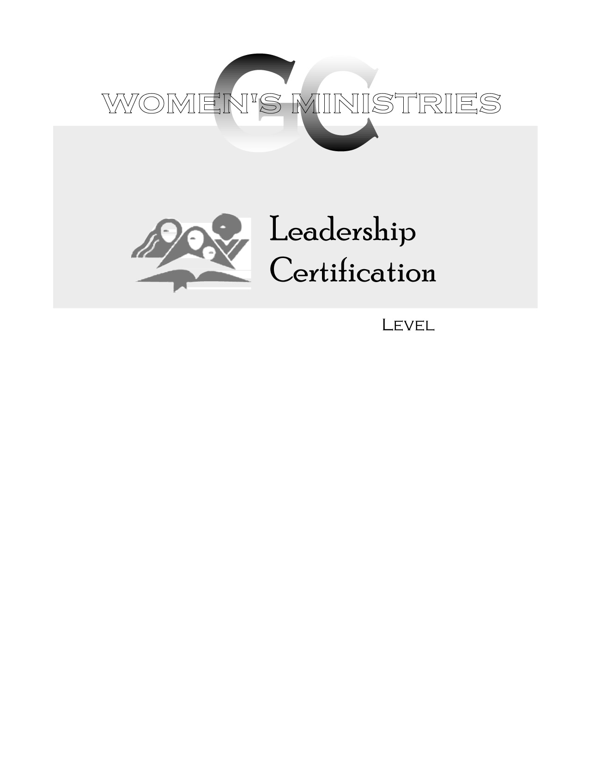
2
Small Group Ministries and Support Groups

Alicia Patterson
2
2
Small Group Ministries and Support Groups

Overheads
2
Small Group Ministries and Support Groups

Handouts
2

