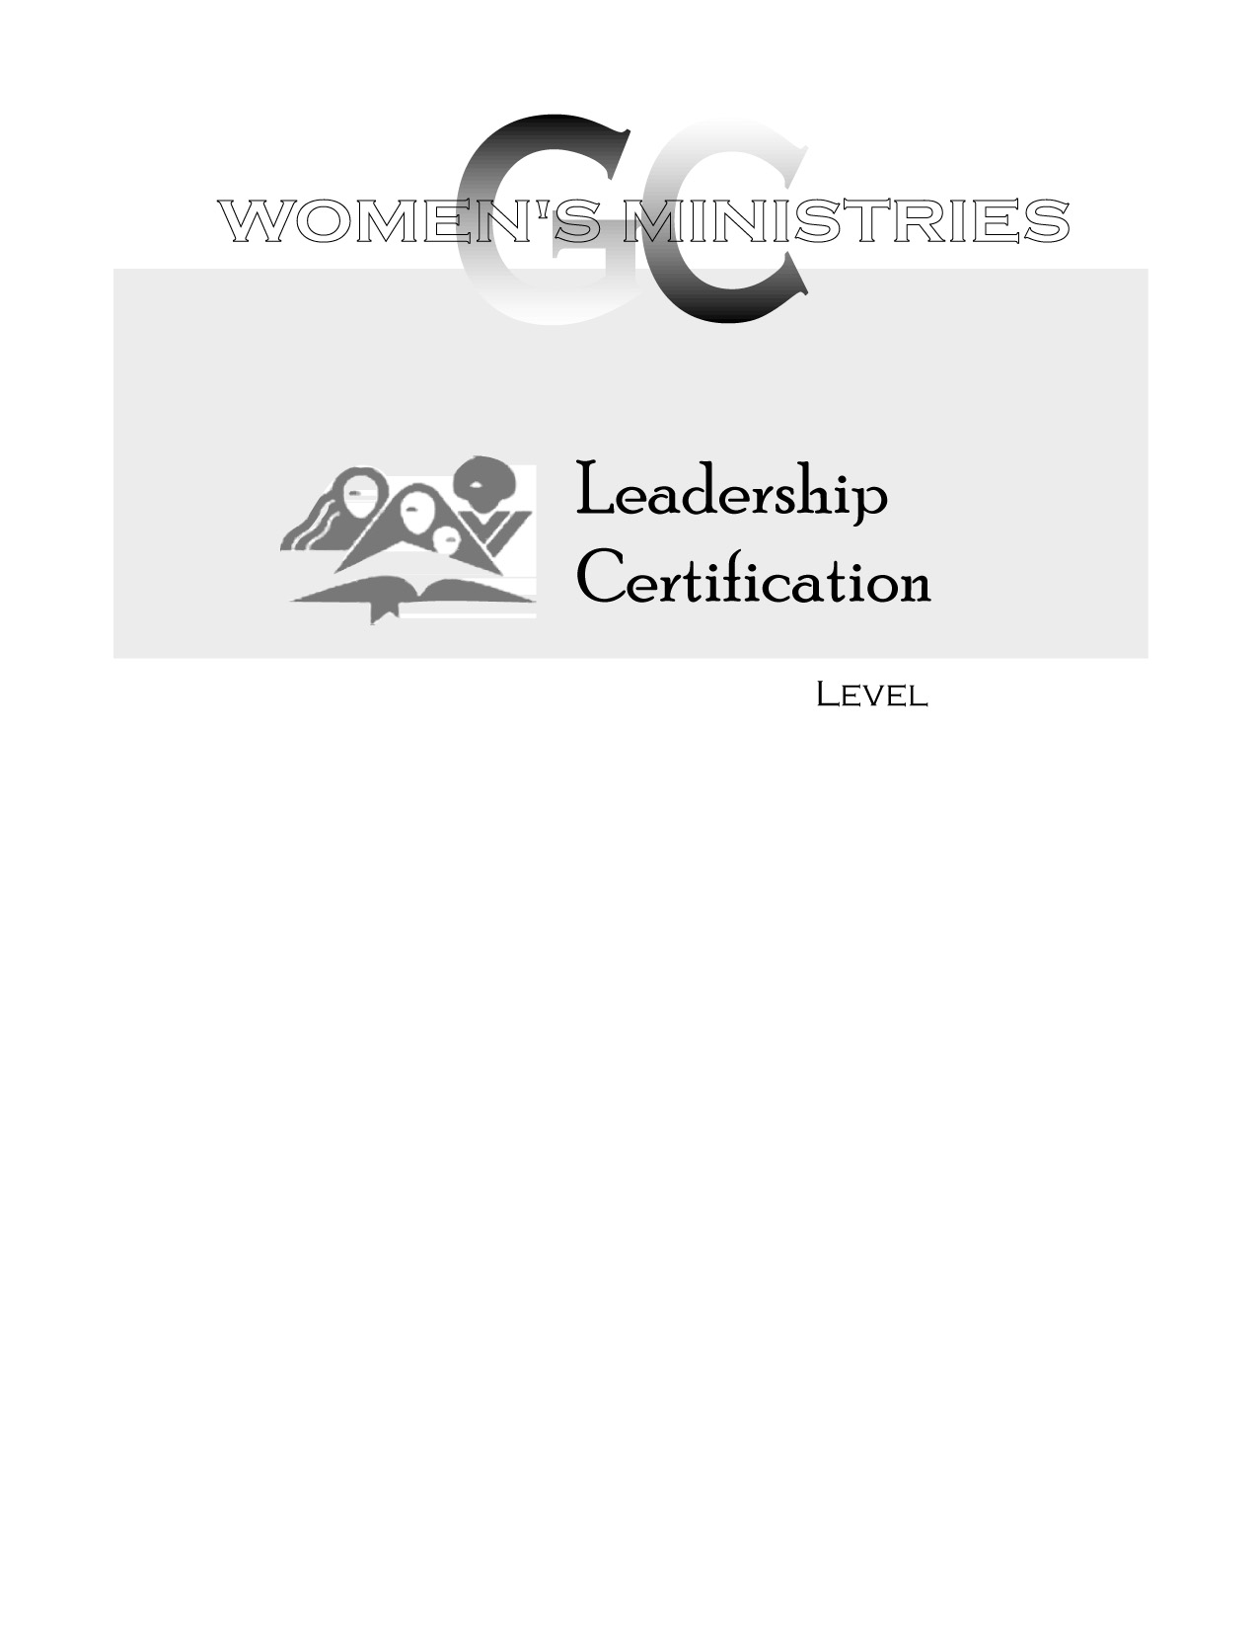
2
Writing and Producing a Newsletter

Iris Stovall
2
2
Writing and Producing a Newsletter

Handouts
2
Writing and Producing a Newsletter

Overheads

