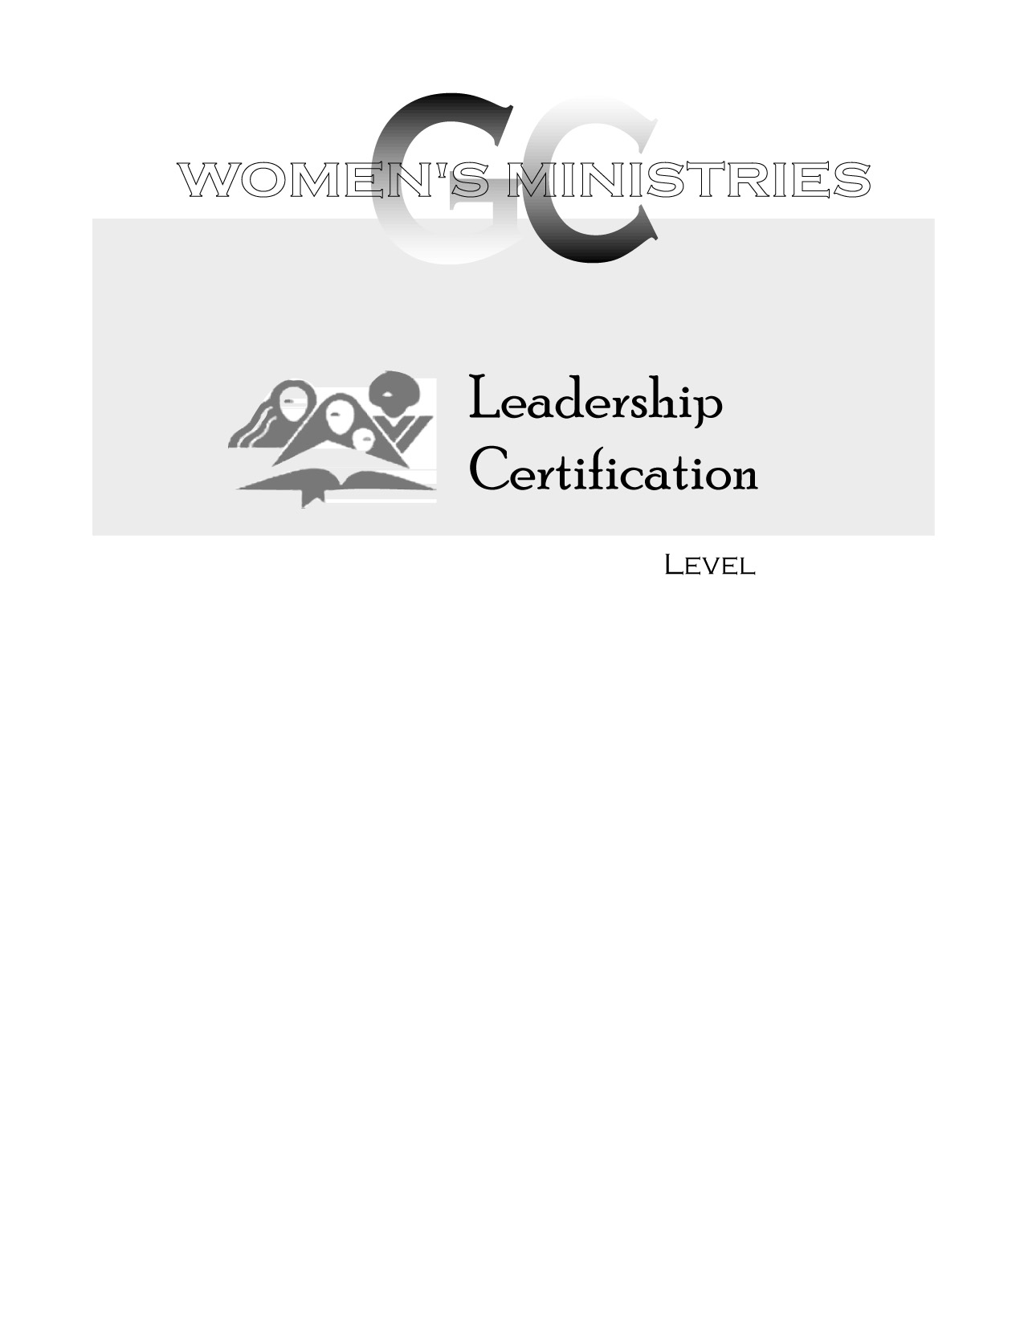
2
Writing Proposals

Mabel Valdivia
2
2
Writing Proposals

Handouts
2
Writing Proposals

Overheads

