Why Proposal Writing?

A strong proposal that is well-written and well-organized can bring in substantial income for your organization.

Proposal Writing from a Development Context

The sort of proposals we are likely to write will most likely be for development projects—those that promote quality of life improvements for the participants and remove obstacles that prevent them from reaching their full potential.

What Makes A Good Proposal?

- Compelling
- Participant-Focused
- Feasibility
- Cost-Effectiveness
- Relevance
- Sustainability

Basic Principles of Proposal Writing

- Free of typographical errors
- Write in easily understandable English
- Write concisely
- Support your assertions with evidence and documentation
- Get honest feedback

Types of Proposals

- Letter of Intent—Generally a two page summary mailed when donors wish to see a brief description of the project.
- A Letter Proposal—Most often requested by corporations
- Long-Proposal Format—This is the type of format most often requested by foundations and government donors.

Overview of a Proposal

Core Components:
- Problem/Need Statement
- Goal(s) and Objective(s)
- Methodology
- Monitoring and Evaluation
- Budget

10 Steps for Writing Proposals

Step 1:
Gathering and Organizing Data

- Demographic Information
- Geography
- Living Conditions
- Health Conditions
- Economic Indicators
- Social Structure
- Previous Development

Important Contacts

- Government officials (optional, but sometimes a required formality)
- Donor representative(s) in the country
- Program Officer(s) of foundations

Step 2:
The Need Statement

Proposals are written to convince a donor that there is a need.

Focus Questions

- Who are the people in need?
- What is their need?
- When does the need occur?
- Where are the people in need located?
- Why does this need occur?

Other Questions:
- What evidence proves this need?
- What changes will occur if the need is met?
- What will be better?


Tips for Writing the Need Statement

- Use hard-core statistics, not assumptions or undocumented assertions
- Be sure that statistics are clear and support your argument
- Use comparative statistics and research when possible
- Make sure all data collection is well documented
- Use touching stories of people as examples
- Focus your explanation of the need in the geographic area you can serve

Step 3:
Stating Goals and Objectives

Definitions:

Goal—a broad statement of the project’s ultimate result.

Objective—a measurable, time-specific result that the organization expects to accomplish through the project; more narrow than goal.

Basic Components of Goals
- A brief description of the target population
- A general, but concise, phrase specifying what will be done
- The location where the project will be implemented
- Time period (only for long-term goals)

Objectives

- Who is involved?
- What will occur during the grant period?
- How much or how little change will occur?
- How long will it take?
- What will be different at the end of this funding period from what was there before?
Step 4:
The Methodology

Questions to consider:
- What needs to be done?
- When will the activities start and finish?
- Who is responsible?
- Why is it being done this way?

Questions to consider (cont):
- What human and material resources are needed?
- How will the participants be selected?
- Are there direct links between methodology and the objectives and need statement?
- Is the method compatible with material, human, and financial resources?

Step 5: Monitoring and Evaluation

Donors expect to know the ways an organization will measure the success of a project.

Purpose

  - Accountability
  - Project Improvement
  - Project Dissemination



Difference between Monitoring and Evaluation

- Monitoring
  - Management and tracking of data and money
  - Data is collected periodically
- Evaluation
  - Detailed analysis of a project to determine success

Step 6:
Sustainability

Too often, the effects of a development project have not continued beyond the funding period. Sustainability is what happens after all funding is gone.

Why is it important?

- Donors want to know how the program will continue after the funding ends
- Communities need to be capable of developing on their own

Helpful Principles for Addressing Sustainability
- Keep the budget lean
- Involve the beneficiary community
- Utilize local material resources as much as possible
- Identify recurring costs and develop a plan for phasing them over to local support or identify sources for possible continued funding
Step 7:
The Budget

Whereas the proposal narrative provides a word description of your project, the budget section is a description in numbers.

Other Budget Considerations

- Exchange rates
- Contingencies
- Income sources

Step 8:
Proposal Summary and Donor Request

The introductory summary is always written after the body of a proposal has been written, never first.

Tips for Proposal Summary

- Always written at the end
- Located after the title page
- Includes
  - Name of fund seeker
  - Total amount needed
  - Total amount requested from donor
  - Specific purpose of the project
  - Location of the project
  - Length of program activity
- One 5-7 line paragraph to 1 page in length

Step 9:
Attachments

Often, but not always, a donor will require additional information about an organization in the form of attachments.

What to Include?

- Overview of the implementing organization
  - Mission statement
  - How it started
  - Institutional goals and significant accomplishments
  - Comparative advantage—what do we have that’s better?
- Board of Directors’ profile
- Implementing staff profiles
- Legal status documentation
- Audited financial statements
- Annual reports

Other Supporting Documents

- Letters of support from communities, local authorities, donor country representatives
- Maps of the project area
- Relevant Forms
- Charts and diagrams regarding health, agriculture, economic indicators, etc.

Step 10:
Putting it Together

In addition to a narrative and attachments, the proposal package includes a title page, table of contents, glossary of terms, and a cover letter.

Required Elements

Cover Letter
  - 1 page in length
  - Make reference to any previous communication with the donor
  - Provide a brief description of funds requested, length of program, and program purpose
  - Thank the reader for their consideration of the proposal
  - Signed by someone authorized by the organization to undertake projects

Required Elements

Title Page
  - Name of the institution to which the proposal is being submitted
  - A brief statement regarding the purpose of the proposal
  - Date of submission
  - Name of the institution making the request
  - Name, official title, mailing address, telephone/fax numbers, and e-mail of the contact person

Required Elements

- Table of Contents (generally uses Roman numerals)
  - The headings of each major section of the proposal
  - The subheadings of units within each section
  - The title of each attachment

The Future
Developing Future Funding Strategies
Identifying Potential Donors
- Individuals
- Private foundations
- Corporations
- Governments
- Local church
- Local conference
- Union conference
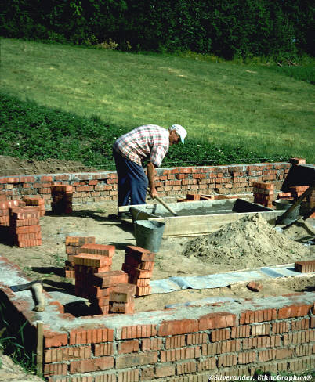
- Adventist Community Services
- ADRA

