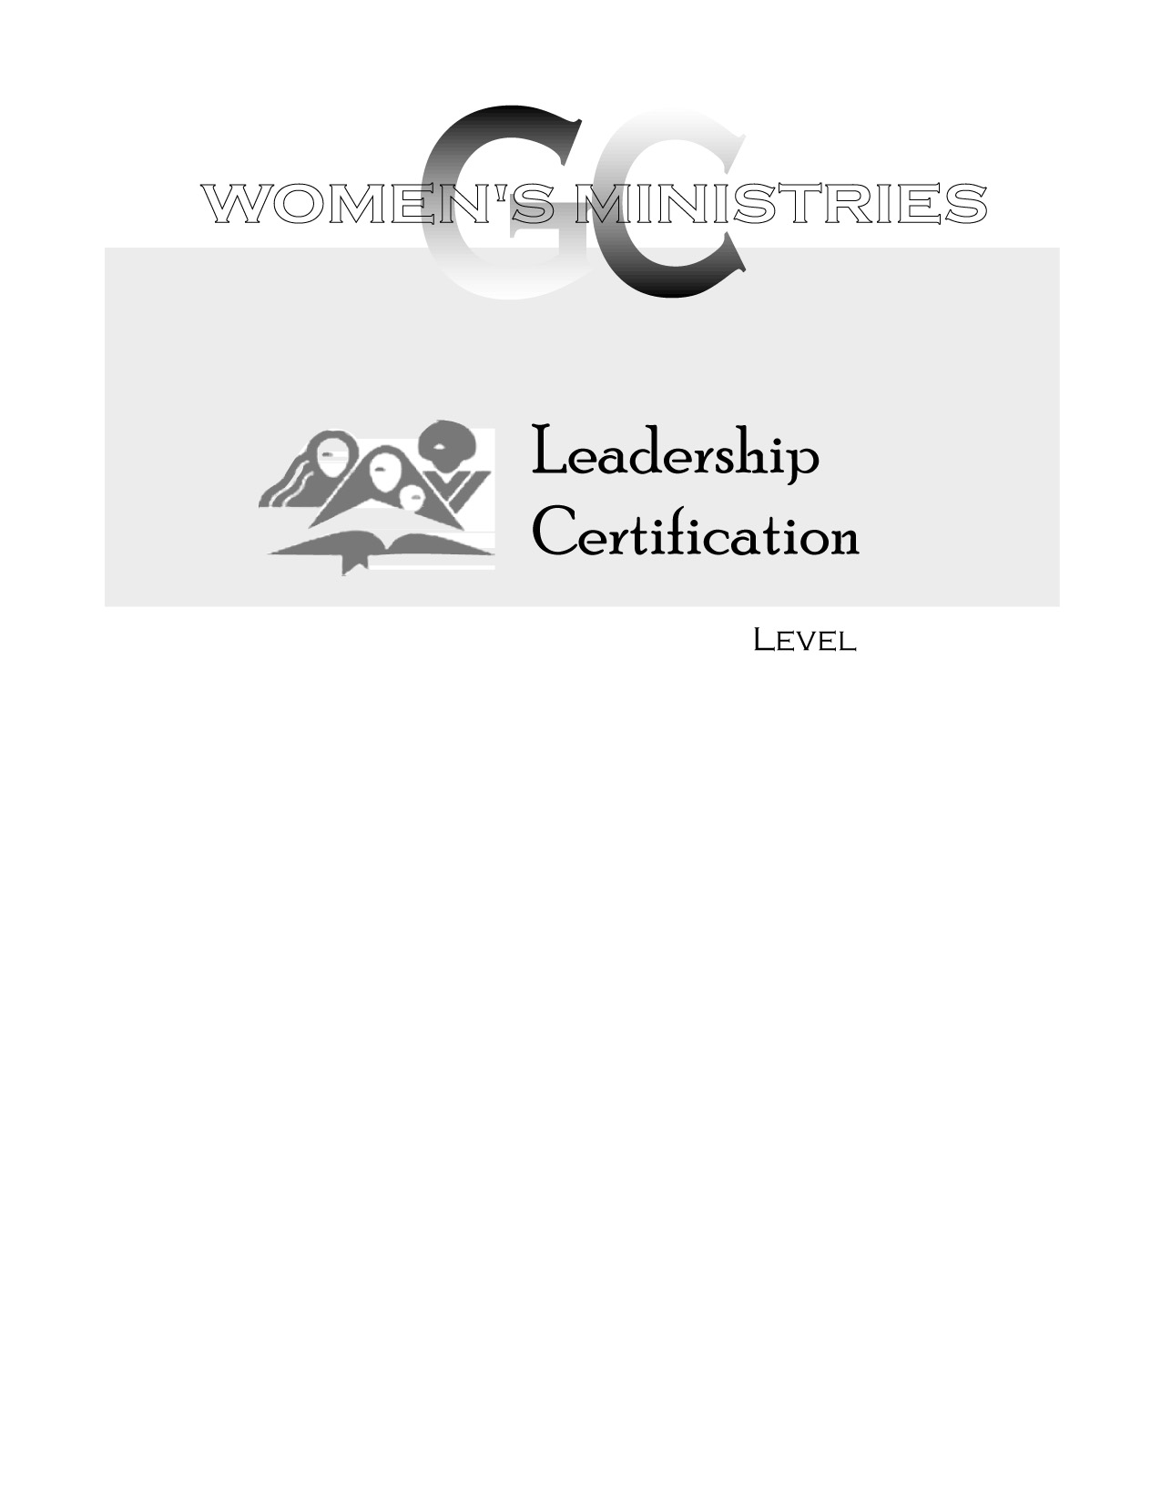
2
Woman to Woman in Islam

Karen Porter
2
2
Woman to Woman in Islam

Handouts
2
Woman to Woman in Islam

Overheads

