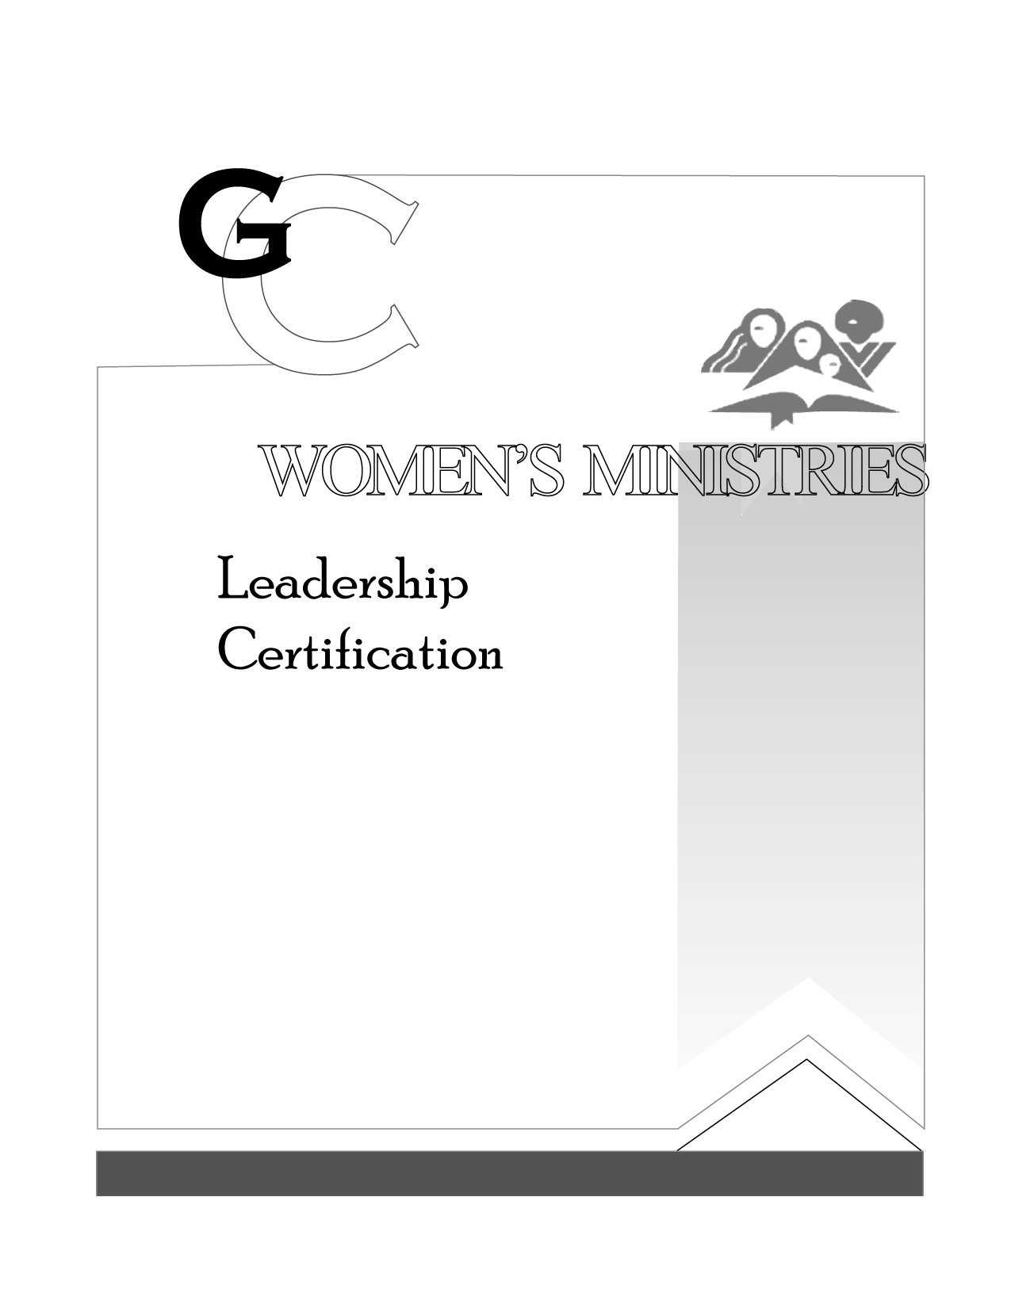
3

Fellowship Activities

By Evelyn Glass

PRESENTR’S SCRIPT

L E V E L

3

Fellowship Activities

HANDOUTS

L E V E L

3

Fellowship Activities

OVERHEADS

L E V E L

