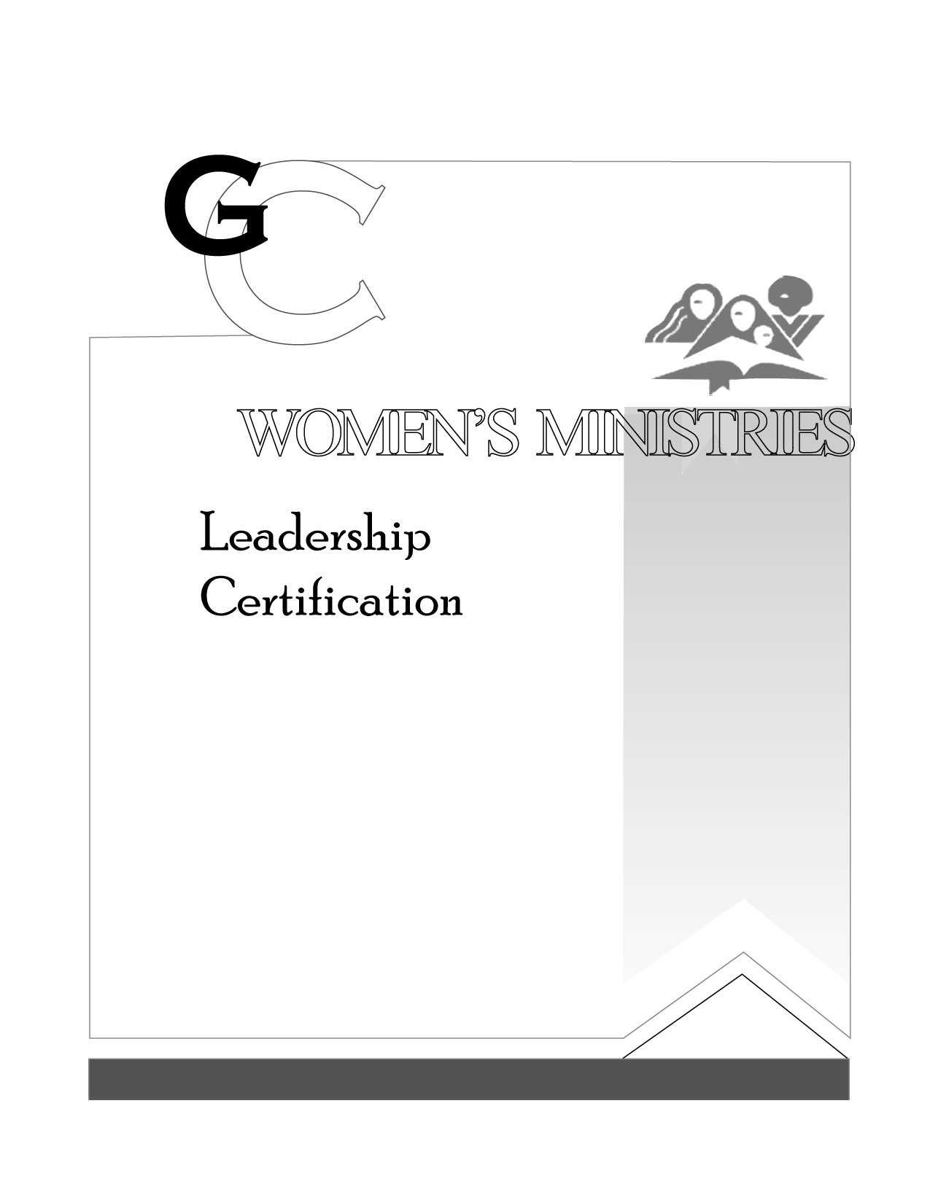
3

How to Prepare a talk Sermon
by Beth Chagas

Presenter’s Script

L E V E L

3

How to Prepare a talk Sermon

HANDOUTS

L E V E L

3

How to Prepare a Talk Sermon

OVERHEADS

L E V E L

