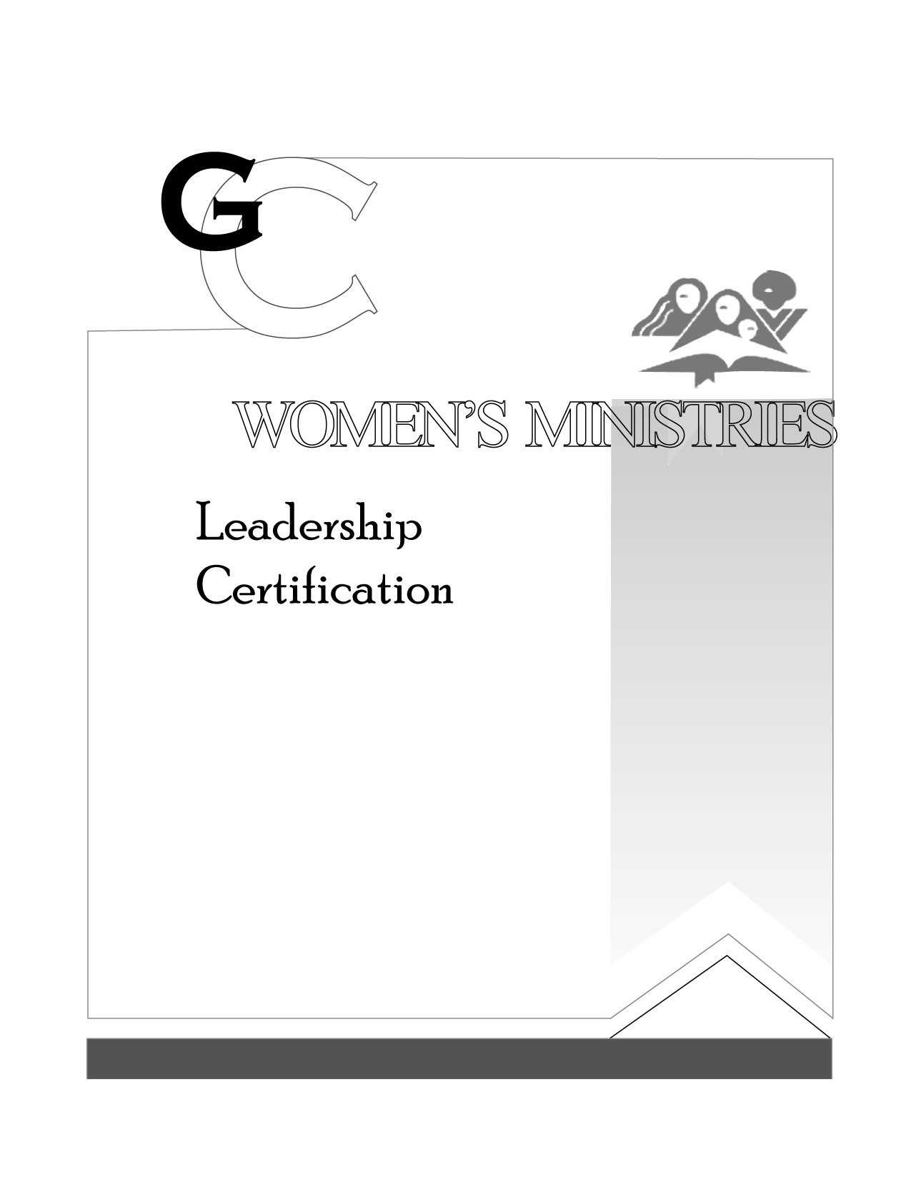
3

Spiritual
Gifts

By Birthe Kendel

Presenter’s Script

L E V E L

3

Spiritual
Gifts

HANDOUTS

L E V E L

3

Spirituial Gifts

OVERHEADS

L E V E L

