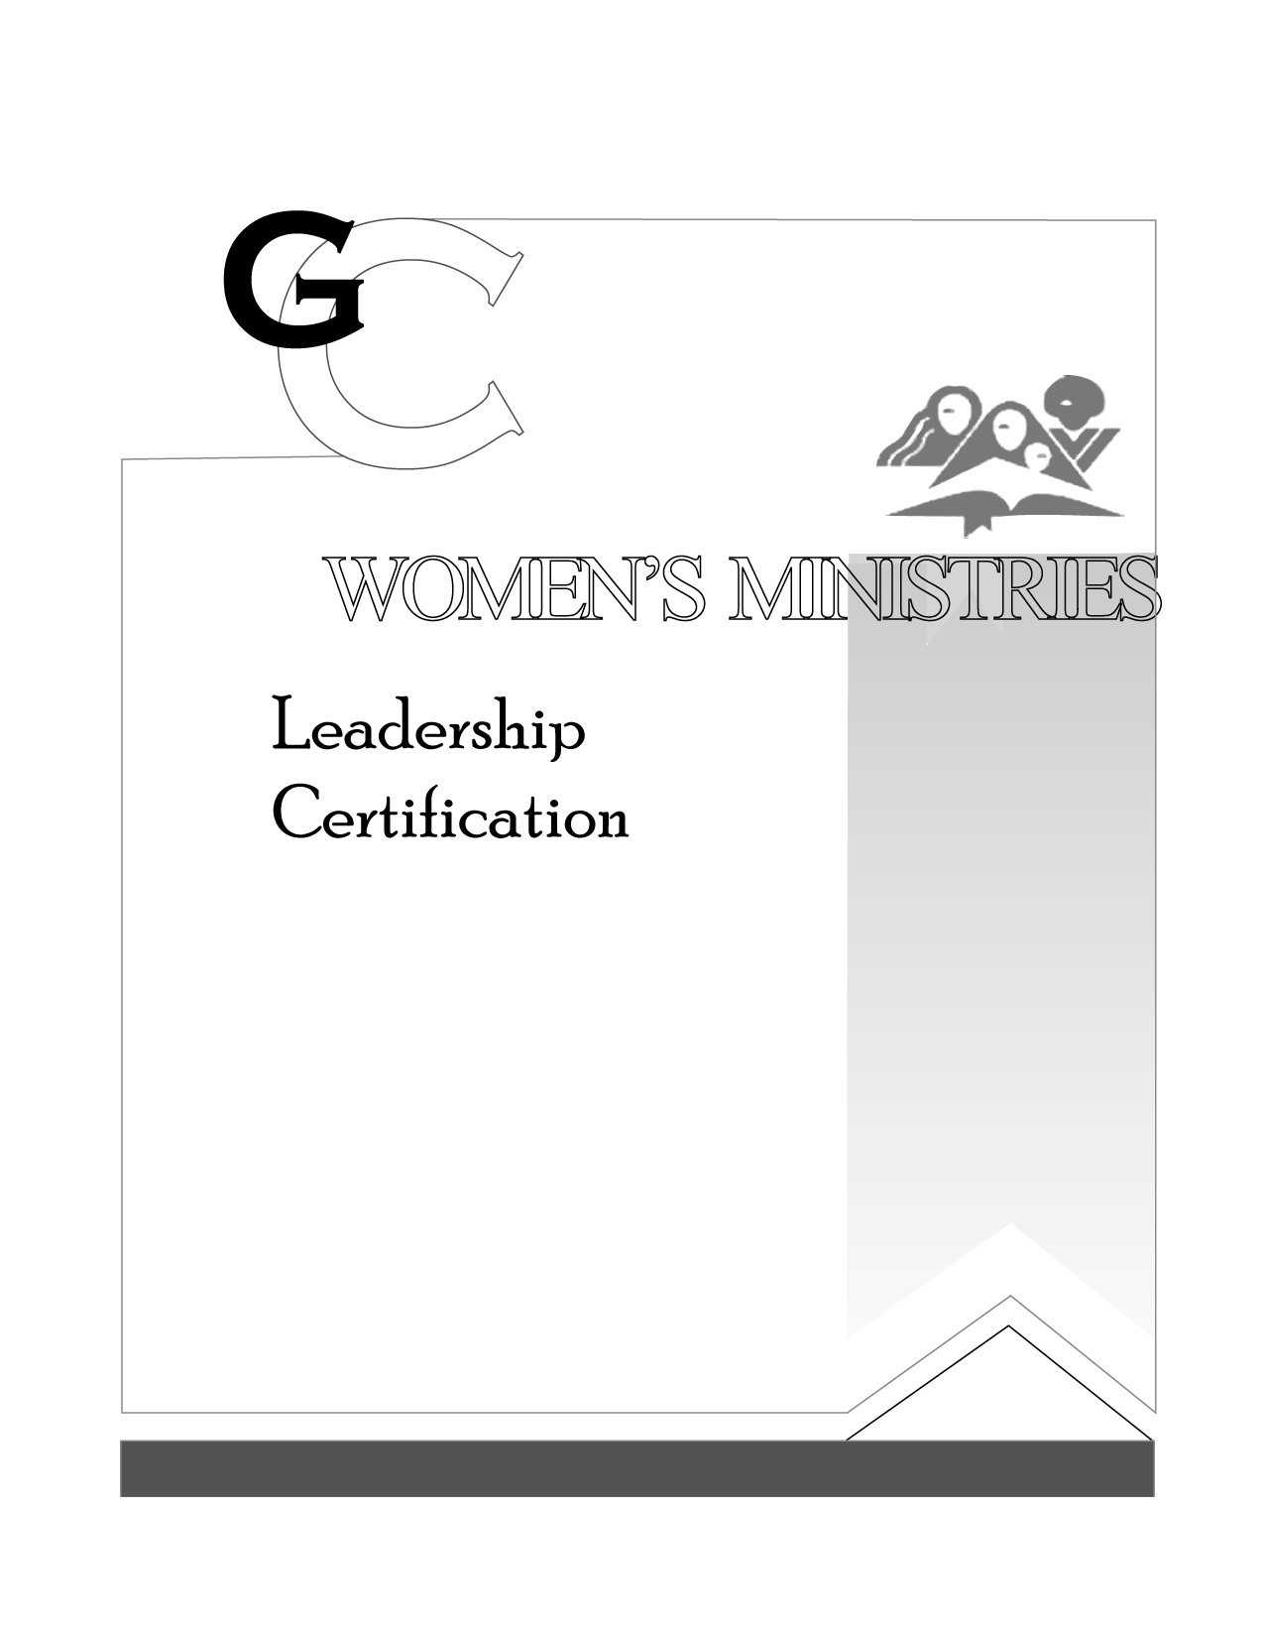
3

Women’s Roles in E.G. White

Cindy Tutsch & Laura Wibberding

Presenter’s Script

L E V E L

3

Women’s Roles

in E.G. White

HANDOUTS

L E V E L

3

Women’s Roles in E.G. White

OVERHEADS

L E V E L

