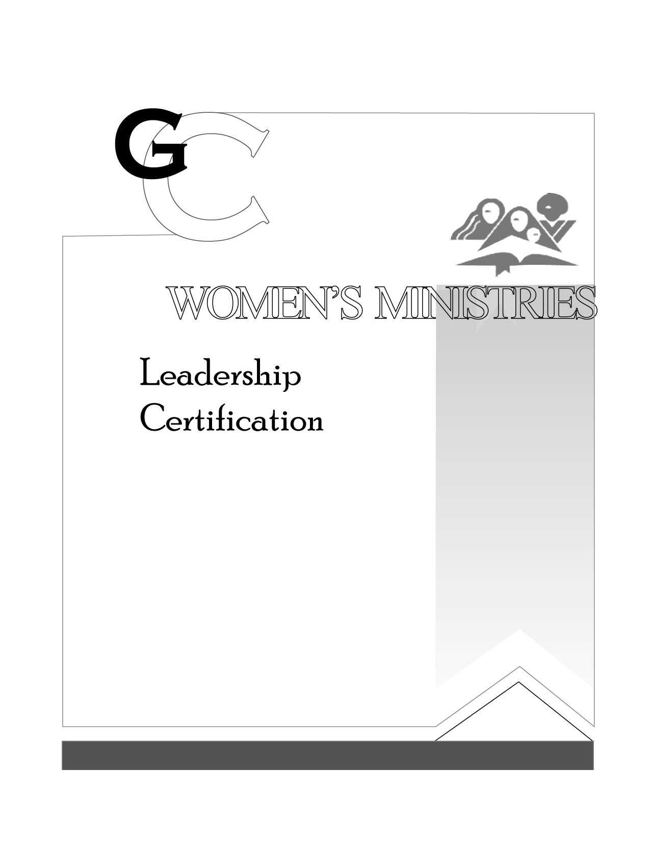
3

Women’s Social and Legal Issues
by Glenda-mae Greene

PRESENTER’S SCRIPT

L E V E L

3

Women’s Social and Legal Issues

HANDOUTS

L E V E L

3

Women’s Social and Legal Issues

OVERHEADS

L E V E L

